Lockdown and emergency measures in Europe – current state of play (Update 05/11/2021)
Notes:
- In general, distances of 1.5 metres must be kept as part of physical distance measures. This document only specifies where there are different national requirements.
- In general, masks must be worn in closed public spaces. This document only specifies additional or lesser national requirements.
- The EU Digital Covid Certificate entered into force on 1 July 2021. Certificates certifying an individual’s vaccination, recovery or test results are delivered nationally but rendered interoperable at EU level. Most European countries require individuals to show a certificate to enter certain establishments or attend events. EU Digital Covid Certificate holders also face much lighter, or no restrictions for intra-EU travel, and several countries only authorise entry to travellers with proof of vaccination, recovery or negative test.
- On 13 October 2021, the Council adopted a Recommendation to facilitate travel and coordinate restrictions.
- On 9 November 2021, the Council updated the list of third countries for which COVID-19 travel restrictions should be lifted.
- Figures for infection rates over the past 14 days per 100.000 inhabitants in countries covered by this document were gathered on 10 November 2021.
- In the EU/EEA, 75,9% of the population above 18 years of age and 64.8% of all the population is fully vaccinated. 598,5 million vaccination doses have been administered.
- Vaccination figures in this document cover the total population (they previously covered the adult population only).

Austria  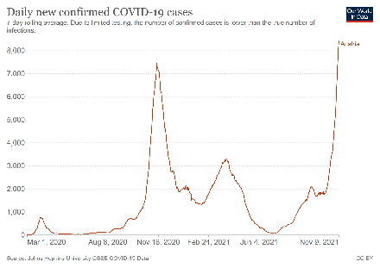  *8410 new cases recorded on 09.11.2021 | Infection rate (cumulated past 14 days): 1049 cases per 100.000 inhabitants (up from 230 cases per 100.000 inhabitants on 8 September 2021).  On 10.11.2021, 67.6% of the population received at least one dose of Covid-19 vaccine and 63,4% of the population is fully vaccinated.  Covid Certificate: The following places require entry documents. This document must either show a negative COVID test, a vaccine certificate or proof of past infection. The EU Digital COVID Certificate is now accepted as proof alongside all previous forms of proof.  Bar/restaurant Nightclub Hotel Public transport Cultural events/gatherings Gym/Sport facilities Shop/shopping mall Personal care services  COVID certificate required? Yes Yes Yes No Yes Yes No Yes  General information: Face masks are required on public transport and in some public spaces (e.g. shops, post offices, retirement homes). Fewer requirements apply to holders of a certificate. There is no more distance requirement in place. A national ‘Corona Traffic Light‘ is in place, assigning each Austrian district to one of 5 categories. In Vienna, Salzburg, Upper Austria, Styria, Carinthia, Tirol, Vorarlberg and Lower Austria (from 8 November), FFP2 masks are mandatory in all shops and some public indoor spaces (museums, libraries etc.) regardless of vaccination status  Shops, museums, culture and leisure facilities are open. Events can take place without a curfew or capacity restrictions. There is no more restriction on gatherings, but meetings with 25 and more participants, all guests have to provide proof of their low epidemiological risk; meetings with 100 and more participants have to be notified to the district administration; and meetings with 500 participants or more need to be approved by the authorities.  A contact tracing tool Stopp Corona App is available. Protocol for hospitality: Safe hospitality  Hotels: Accommodation establishments are open. To receive services, guests have to register and hold a certificate. Guests do no longer have to wear a mask nor keep a minimum distance to other guest groups. Having a valid entry test is required when making use of hotel services, such as visiting a hotel's restaurant.  Bars and restaurants: Catering establishments may receive customers with comprehensive concepts in place. As of 1 July, there is no more limit per table, no more minimum distance between groups of guests and no more mandatory closing hour. Guests must show a certificate and leave contact details if their visit exceeds 15 minutes.  Nightclubs: have reopen since 1 July 2021. A negative PCR test or a vaccine certificate is required (proof of past infection is not sufficient).  Vaccinated guests have to be fully vaccinated to enter night clubs, bars and discos  Traveling restrictions: Anybody entering Austria has to show their entry document (a negative COVID test, a vaccine certificate or proof of past infection). Without proof of vaccination, it is needed a pre-travel clearance form not more than 72 hours before entry to Austria and self-isolate for 10 days.  - Travellers from countries with a low incidence rate (most European countries and some non-European countries) who can show proof of negative test/vaccination/past infection can enter the country for tourism purposes without needing to self-isolate nor request pre-travel clearance.  - Travelers from virus variant areas can only enter for essential reasons, must register digitally in advance, must have a negative PCR test and operate a 10-day quarantine.  - Concerning the other countries, entry is possible for fully vaccinated travellers without self-isolation and registration. Not fully vaccinated travellers need to self-isolate for 10 days and to register digitally.  Please find more information on travel restrictions here.
Azerbaijan  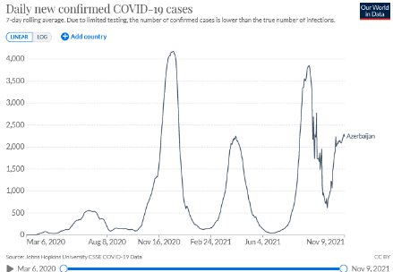  *2243 new cases recorded on 09.11.2021 | Infection rate (cumulated past 14 days): 297 cases per 100.000 inhabitants (down from 449 cases per 100.000 inhabitants on 8 September 2021)  On 09.11.2021, 48,9% of the population received at least one dose of the vaccine and 43,4% of the population is fully vaccinated against Covid-19.  General information: The Cabinet of Ministers of Azerbaijan has issued a decree announcing the special quarantine regime will remain in effect until January 1, 2022, according to an October 29, 2021 decision by Azerbaijan’s Cabinet of Ministers. There are currently no restrictions on travel around Azerbaijan. Local lockdowns could be applied at very short notice. Most businesses and services are open. Some public places such as gyms and places of worship are only accessible for those with a ‘COVID-19 Passport’ showing proof of vaccination or immunity. Since 1 September 2021, the list of public places where a ‘COVID-19 Passport’ must be presented in order to enter is extended to restaurants, cafes, shopping centres, hotels, hairdressers and beauty salons, museums and galleries, and most public and private events. The Cabinet of Ministers also announced that, beginning October 1, 2021 recreation and entertainment venues (including clubs), cultural facilities, and cinemas will be allowed to operate at fifty percent capacity; proof of vaccination will be required for those 18 and over. Travellers to Azerbaijan, who have a ‘COVID-19 passport’ issued from their country of residence, can also present this in either a digital format, or as a printed certificate, to gain access to these locations.  Most public transportation, including the Baku Metro, reopened on May 31, including weekend operation beginning October 1, 2021  Hotels are open. Guests must present a ‘Covid-19 passport’.  Bars and restaurants: activities of on-site customer service in catering facilities, as well as cafes, teahouses and similar establishments) from 06:00 to 00:00 have resumed since 01.02.2021. Guests must present a ‘Covid-19 passport’.  Travel restrictions: There are a limited number of commercial flights to and from Baku. There is no longer a requirement for arrivals to Azerbaijan to self-isolate. Nationals from the following countries are allowed to travel to Azerbaijan: Argentina, Australia, Austria, Bahrain, Belgium, Brazil, Brunei, Cambodia, Canada, Chile, China, Costa Rica, Croatia, Cuba, Czech Republic, Denmark, Ecuador, El Salvador, Estonia, Finland, France, Germany, Greece, Hong-Kong (PRC), Hungary, Iceland, Ireland, Israel, Italy, Japan, Kazakhstan, Kuwait, Latvia, Lithuania, Luxembourg, Malaysia, Maldives, Malta, Mexico, Mongolia, Montenegro, Morocco, New Zealand, Norway, Oman, Panama, Poland, Portugal, Qatar, Russia, Saudi Arabia, Serbia, Singapore, Slovakia, Slovenia, South Korea, Spain, Sweden, Switzerland, The Netherlands, Turkey, UAE, United Kingdom, Uruguay and USA.  - It is mandatory to have a negative PCR test, made no earlier than 72 hours.  - In addition to the test, citizens over 18 years old must have a COVID passport or a document about a recent illness.  Please find more information on travel restrictions here.
Belgium  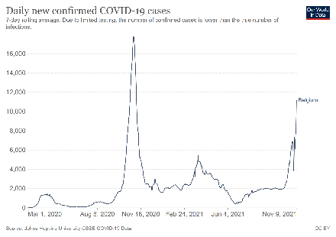  * 11168 new cases recorded on 09.11.2021 | Infection rate (cumulated past 14 days): 901 cases per 100.000 inhabitants (up from 241 cases per 100.000 inhabitants on 8 September 2021)  On 10.11.2021, 75.8% of the population received at least one dose of Covid-19 vaccine and 74.6% of the population is fully vaccinated.  COVID certificate: The “Covid Safe Ticket” was introduced on 13.08.2021 but so far is requested for large outdoor (>5000 participants) and indoor (>3000 participants) events. However the EU Covid certificate lifts many travel-related restrictions for intra-EU travels. From 26 October Uniform measures in Belgium have been introduced. The recent increase in the number of infections and hospitalisations has led the Federal Government to take various urgent measures for the next three months. The idea is above all to harmonise the rules in the three Belgian regions, hardening measures in the Flemish and Wallon regions.  Bar/restaurant Nightclub Hotel Public transport Cultural events/gatherings Gym/Sport facilities Shop/shopping mall Personal care services  COVID certificate required? Yes No Yes Yes Yes No Yes Yes  General information: Wearing a mask is mandatory in most indoor public spaces as well as outdoor if social distancing cannot be ensured. Restrictions regarding private gatherings are lifted (except Brussels, where there is an 8 person limit). For the events sector, restrictions on events with less than 200 spectators indoors and less than 400 spectators outdoors remains in force in Brussels Capital Region.  Teleworking remains necessary when possible with one day on site per week. Presence of maximum 20% of workers simultaneously (or maximum 5 in SMEs with less than 10 workers). As of November 1st, all Belgian federated entities are committed to making the application of the Covid Safe Ticket mandatory in all hospitality and fitness establishments in our country.  Non-essential stores are open with safety measures (wear face masks, disinfect hands). It is allowed to shop with another person of the same household. The capacity in the stores has been reduced. Weekly markets may take place. It allowed to visit markets in groups of 8. The night shops are open until 01:00 AM. Hairdressers and other non-medical contact professions, such as pedicure and beauty salons, are open.  Hotels: Accommodations (hotels, B&B's etc.) are allowed to welcome guests. Hotel restaurants, bars and communal facilities (pool, fitness) are also open.  In Brussels, a safety label has been developed to reassure visitors that the site, venue or establishment in question is safe. The criteria for receiving such a label are based on checklists drawn up on the basis of specific protocols, developed in close cooperation with sectoral entities and representatives. Information for the other regions is available at: Health protocols for Flanders (in Dutch); Health protocols for Wallonia (in French).  Bars and restaurants: Restaurants, bars and cafés are open indoors and outdoors. Restrictions regarding opening hours and limits to group sizes only apply in Brussels, where establishments must close at 01:00 and a maximum of 8 people per table is allowed. . Night clubs and dance halls can also reopen, provided that the Covid Safe Ticket is used.  Travel restrictions: Travelers from all countries must complete the Passenger Locator Form (PLF) before arriving.  - Travelers coming back from a very high-risk country in the past 14 days are not allowed to enter Belgium except if they have an essential reason.  - Travellers coming from a green or orange zone do not need to get tested or do a quarantine.  - Travelers from a red zone in the European Union must have a vaccination, a recovery certificate or a negative result of PCR test.  - Travelers from a red zone outside the European Union can only travel to Belgium for essential reasons or if they have an approved vaccination certificate with full vaccination.  Please find more information on travel restrictions here.
Bulgaria  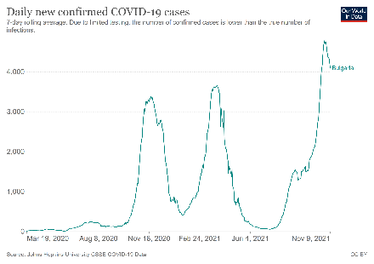  *4091 new cases recorded on 09.11.2021 | Infection rate (cumulated past 14 days): 882 cases per 100.000 inhabitants (up from 292 cases per 100.000 inhabitants on 8 September 2021)  On 10.11.2021, 25.2% of the population received at least one dose of Covid-19 vaccine and 22.7% of the population is fully vaccinated. Bulgaria has the EU’s lowest vaccination rate  COVID certificate: Bulgaria issues covid certificates which are essentially used with regard to travel restrictions.  Bar/restaurant Nightclub Hotel Public transport Cultural events/gatherings Gym/Sport facilities Shop/shopping mall Personal care services  COVID certificate required? No No No No No No No No  General information: No curfew, but social distancing and restrictive measures are in place. Teleworking is recommended whenever possible. There is no interdiction to move within the country.  On November 4 a wide range of social gatherings were suspended at least until November 30: the holding of public events (e.g. conferences, seminars, competitions, etc.); cultural and entertainment events (namely film screenings, theatre performances, stage events, concerts, exhibitions, dance classes, creative and musical arts, etc.); visits to fitness centres, spas and swimming pools; or shopping malls. Only essential shops (grocery stores, pharmacies, medical and vaccination establishments, drugstores, opticians, pet shops, banks, postal and courier service providers etc.) remain open. Private gatherings (baptisms, weddings, etc.) are allowed with the participation of no more than 15 people indoors and 30 people outdoors.  Commercial and administrative establishments must monitor the number of customers on the site, allowing the presence of 1 person / 8 square meters. Shops, shopping centers, and markets should close at 21.00. Pharmacies and gas stations can remain open longer.  ViruSafe is used to track and trace through a daily tracking for symptoms and health status with a voluntary GPS-based functionality. Health protocols for tourism services and tourists (in English).  Hotels are open.  Bars, restaurants and cafés: suspended?  According to Bulgarian classification:  - Passengers arriving from "Green" and “Orange” countries and holding the EU Digital COVID certificate can enter Bulgaria. Without the EU Digital COVID certificate, a document showing a negative result of a rapid antigenic test carried out within 48 hours before entering the country must be shown.  - If travellers from green and orange countries cannot provide any of these documents, a 10-day quarantine is imposed. Travellers can shorten the quarantine if they submit a negative test (molecular or antigen) performed within 24 hours from entering the country.  - In addition to the previous measures, travellers from “Red” countries must also provide a negative molecular (PCR) test, performed within 72 hours before travelling.  Please find more information on travel restrictions here.
Croatia  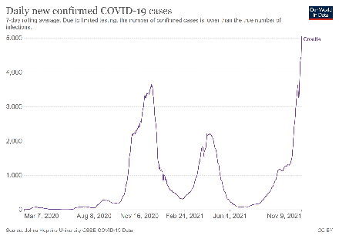  *5039 new cases recorded on 09.11.2021 | Infection rate (cumulated past 14 days): 1425 cases per 100.000 inhabitants (up from 202 cases per 100.000 inhabitants on 8 September 2021)  On 10.11.2021, 48.2% of the population received at least one dose of Covid-19 vaccine and 45% of the population is fully vaccinated.  COVID certificate: the EU Covid Digital Certificate is used for the attendance of cultural and sports events.  Bar/restaurant Nightclub Hotel Public transport Cultural events/gatherings Gym/Sport facilities Shop/shopping mall Personal care services  COVID certificate required? No Yes No No Yes No No No  General information: There is no restrictions on free movement in the country. Local and regional containment measures can be applied, based on the epidemiological situation.  Public events, gatherings and ceremonies of all kinds must be ended by midnight at the latest, unless it is a public event or gathering attended only by persons with a EUDCC certificate. Gatherings are allowed for no more than 100 people without vaccination certificates and while larger events can admit more than 100 people if they show proof of vaccination or negative tests. Public transport capacity is reduced. Drivers, employees, and passengers are required to wear face masks.  Shops are open, but the general public health recommendations on physical distancing, personal hygiene and disinfection should be maintained. At least 4 square metres of space for each customer must be secured. There is a ban on the sale of alcohol between 23.00 and 06.00. Cinemas, museums, theatres, professional artistic projections/exhibitions/performances can operate with limited capacity and must close at 23.00.  In July 2020 the government launched the STOP COVID-19 app. Croatia travel information and general measures  Hotels: Following the general public health recommendations on physical distancing, personal hygiene and disinfection, these services are open. Accommodations can only cater or serve guests who are staying in the accommodation. For more details: recommendations for hotels and renters  Bars and restaurants: Restaurants and bars are open provided that social distancing and hygiene measures are in place, with a maximum number of 10 guests in the common areas of the facility and working hours from rom 6.00 AM to12.00 AM. Nightclubs are allowed to work and serve all guests without working hours, but only in open spaces and provided that the entrance to their premises allowed only to persons holding an EU digital COVID  Travel restrictions:  - Passengers from an EU member state can travel to the Republic of Croatia without having to prove or justify their reasons for as long as they fulfil one of the following seven criteria: EU Digital Covid Certificate, negative PCR (taken 72h before arrival) or antigen test (48h), a vaccination certificate, proof of recovery from Covid, proof of recovery and first dose of vaccination, pay for a test on arrival, confirmation of a first dose.  - Passengers from a non-EU member state can travel to the Republic of Croatia without having to prove or justify their reasons for as long as they fulfil one of the following five criteria: negative PCR (taken 72h before arrival) or antigen test (48h), a vaccination certificate, proof of recovery from Covid, proof of recovery and first dose of vaccination, pay for a test on arrival.  Please find more information on travel restrictions here.
Cyprus  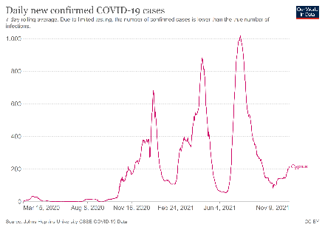  *215 new cases recorded on 09.11.2021 | Infection rate (cumulated past 14 days): 296 cases per 100.000 inhabitants (down from 346 cases per 100.000 inhabitants on 8 September 2021)  On 10.11.2021, 68,4% of the population received at least one dose of Covid-19 vaccine and 66,5% of the population is fully vaccinated.  COVID certificate: venues with more than 20 people are restricted to those with a valid “SafePass,” defined as either a negative (PCR or rapid) test, proof of vaccination, or proof of having contracted coronavirus. Only the police or health officials have the right to request these proofs. The EU Digital Covid Certificate also applies. For tourists, proof of a Cyprus Flight Pass suffices. That said, from November 22 “SafePass” possession checks via the CovScan application will be obligatory.  Bar/restaurant Nightclub Hotel Public transport Cultural events/gatherings Gym/Sport facilities Shop/shopping mall Personal care services  COVID certificate required? Yes Yes Yes Yes Yes Yes Yes No  General information: On October 8, new relaxation measures were introduced, being extended on October 29 by the Council of Ministers approved until 2 December 2021.  Businesses are allowed to operate under strict guidelines. In cinemas, museums and indoor attractions, a maximum of 50% capacity is allowed. The maximum number of people allowed at public events is 300 indoors and 350 outdoors subject to the distancing measures. This number can be also increased to 75% of capacity if all attendants have a “SafePass”. Indoors religious ceremonies, stadiums and sport facilities attendance are allowed but limited to 300 persons with “SafePass” or 500 persons provided that only people with a full vaccination certificate or a COVID-19 recovery certificate within the last 6 months enter the premises.  Retail shops are open between 08:30am and 9:00pm weekdays on the condition that all restaurant employees undergo PCR tests every 15 days. Other retail trade enterprises including shopping centres, malls and large stores, are open. One customer per 10 square metres is allowed. The operation of retail shopping centres, department stores and the rest of the retail trade is permitted provided that the measure of 1 person to 10 sq.m. of useful space is observed.  Hotels: the operation of hotels or/and tourist accommodation units is permitted subject to the guidelines of the Ministry of Health and the Deputy Ministry of Tourism. A “SafePass” or equivalent is required for attending all indoor and outdoor areas and premises where subject to the distancing measures, more than 20 people may gather at any time, including the employees. For more details: recommendations for hotels and renters  Bars and restaurants: Restaurants and cafes may provide dine-in services and night clubs are opened with a maximum of 50% capacity. A “SafePass” or equivalent is required for attending all indoor and outdoor areas and premises where subject to the distancing measures, more than 20 people may gather at any time, including the employee. Restaurants and late night clubs are limited to 300 persons with “SafePass” or 500 persons provided that only people with a full vaccination certificate or a COVID-19 recovery certificate within the last 6 months enter the premises.  Travel restrictions: Cyprus is following a colour-coded system according to the epidemiological situation. All passengers have to submit, all the information and documents required to obtain the CyprusFlightPass. Travellers may still be subject to random testing upon arrival and are still obliged to follow all destination protocols.  - Holders of a vaccination-based or recovery-based EUDCC will be exempt from any additional testing upon entering Cyprus.  - Holders of a test-based EUDCC will need to follow the measures based on the colour categorisation of their country of departure  Please find more information on travel restrictions here.
Czech Republic  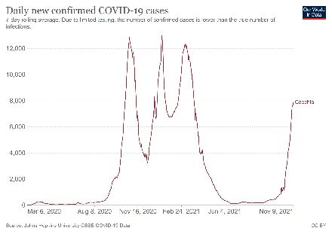  *7878 new cases recorded on 09.11.2021 | Infection rate (cumulated past 14 days): 866 cases per 100.000 inhabitants (up from 29 cases per 100.000 inhabitants on 8 September 2021)  On 10.11.2021, 59,1% of the population received at least one dose of Covid-19 vaccine and 57,4% have been fully vaccinated.  COVID certificate: the Covid certificate is widely used in Czechia for the operation of hospitality establishments and other services and events.  Bar/restaurant Nightclub Hotel Public transport Cultural events/ gatherings Gym/Sport facilities Shop/shopping mall Personal care services  COVID certificate required? Yes Yes Yes No Yes No No Yes  General information: There is no curfew anymore and no restrictions regarding free movement.  Currently, celebrations, parties, festivities and similar events are allowed for a limited number of people, 1000 people indoors and 2000 people outdoors. Without presenting a COVID certificate, maximum of 20 people can meet. Theatres, cinemas and concert halls are open. Hairdressers, barber shops and similar services are open. Retail sales and service provision are both permitted. In shopping centres, mass gatherings must be avoided.  General safety measures for establishments: https://koronavirus.mzcr.cz/wp-content/uploads/2020/05/specifikace_pokyny_2505.pdf. Recommended tracing app: eRouška. A system called "smart quarantine" is in place.  Hotels: Accommodation facilities are open. Upon arrival, guests must present a negative PCR test not older than 3 days, or an antigen test not older than 24h, or a vaccination certificate, or proof of recovery from Covid-19 in the past 180 days. Children under 6 years are exempted from these requirements. After 7 days of stay, the test will need to be repeated. Find out more: Accommodation facilities  Bars and restaurants: Bars and restaurants are open. A mask must be worn and can be removed only for eating and drinking. A minimum distance of 1,5 metres between tables must be respected. Maximum 6 guests can sit at the same table (excluding members of the same household). Nightclubs have reopened. Dancing is permitted for persons who have completed vaccinations, proof of illness, or a test up to 24 hours old prior to entry. However masks can only be uncovered when eating or drinking. Find out more: Restaurants and nightclubs  Travel restrictions: Travellers from all countries have an obligation to fill in the Passenger Locator Form before arrival. Countries are classified, according to their epidemiological situation. It is possible to enter Czechia for any reason, including tourism, from all EU+ countries.  - Low and medium risk countries: Passengers must hold a negative pre-departure antigen / PCR test before or after arrival except for persons who had COVID-19 in a EU+ country in the last 180 days or fully vaccinated people. Vaccinated outside of the EU must be approved by EMA or in compliance with the patent of the approved vaccinations.  - High and very high risk countries: Passengers must hold a negative pre-departure PCR test before and after arrival plus a PCR test on the 5th day after arrival at the earliest and self-isolation until the negative result except for persons who had COVID-19 in a EU+ country in the last 180 days or fully vaccinated people.  Please find more information on travel restrictions here.
Denmark  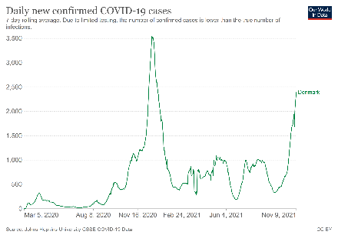  *2391 new cases recorded on 09.11.2021 | Infection rate (cumulated past 14 days): 507 cases per 100.000 inhabitants (up from 192 cases per 100.000 inhabitants on 8 September 2021)  On 10.11.2021, 76.9% of the population received at least one dose of Covid-19 vaccine and 75,7% have been fully vaccinated.  COVID certificate: The requirement to hold a certificate to enter catering establishments has been lifted. The termination of the national COVID-19 restrictions from 10.09.2021 will not affect the current travel and entry restrictions.  Bar/restaurant Nightclub Hotel Public transport Cultural events/ gatherings Gym/Sport facilities Shop/shopping mall Personal care services  COVID certificate required? No No No No No No No No  General information: Masks are mandatory for over-12s only in airports, and advised in hospitals and test centres. There are no special restrictions or measures in the areas of the Ministry of Culture.  Personal services are open. Museums, art venues, libraries, theatres, amusement part etc. are open are opened without restrictions. A Corona passport at businesses and private cultural institutions may be required as they are generally allowed to make their own requirements. Non-essential shops, including shopping malls, are open with strict and specific restrictions. The same applies to museums, amusement parks, theatres, cinemas, venues, zoos, stadiums and other sports venues.  Recommended contact tracing app: smittestop.dk. Health protocols for tourism services and tourists  Hotels are open. Horesta has developed a ’Safe to Visit’ label.  Bars and restaurants: Restaurants and bars are open with no restrictions, however, private business are allowed to require a Corona passport.  Travel restrictions: entrance restrictions are defined by the country or origin and vaccination status .  - Entry from EU/Schengen countries may enter to Denmark without test or quarantine as long as they are fully vaccinated or have been previously infected. All other travellers must either take a test before entry or within 24 hours after entry.  - Entry from countries considered by Denmark as COVID-19 risk countries may enter to Denmark without test or quarantine as long as are fully vaccinated or have been previously infected. All other travellers must either take a test before entry or within 24 hours after entry.  - Entry from all other countries - which are considered by Denmark as COVID-19 high-risk countries must take a test within 24 hours after entry and self-isolate without undue delay. That said, this does not apply in case of having a full vaccination. Otherwise, isolation may be ended with a negative PCR-test taken at least four days after arrival.  Please find more information on travel restrictions and its categorizations here.
Estonia  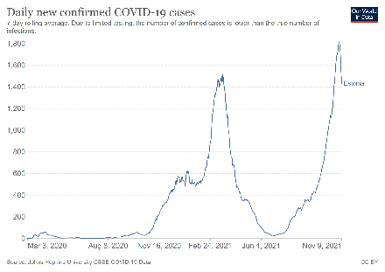  *1431 new cases recorded on 09.11.2021 | Infection rate (cumulated past 14 days): 1695 cases per 100.000 inhabitants (up from 367 cases per 100.000 inhabitants on 8 September 2021)  On 10.11.2021, 60,6% of the population received at least one dose of Covid-19 vaccine and 56,6% have been fully vaccinated.  COVID certificate: The Covid certificate must be presented in all activities taking place in public spaces. All the information can be found in English at kriis.ee  Bar/restaurant Nightclub Hotel Public transport Cultural events/ gatherings Gym/Sport facilities Shop/shopping mall Personal care services  COVID certificate required? Yes Yes No No Yes (partially) No No No  General information: People can move freely within the country. Masks must be worn indoors in all indoor spaces meant for public use, including in rooms where the COVID certificate is checked (including entertainment establishments, events, cinemas, theatres, spas). A COVID certificate has to be presented to participate in sports, training, youth work, hobby activities and informal education, refresher training; at sports competitions, and sports and exercise events; in saunas, spas, water parks and swimming pools; at public meetings and events, including at the theatre, at the cinema, at a concert (including a church concert), at a conference; at museums and exhibition facilities; at entertainment services; at catering establishments in order to eat and drink on the premises  Public meetings and events are allowed a maximum of 6000 people is allowed to attend events indoors and a maximum of 12.000 people is allowed to take part in events in a restricted outdoor area. However, there is a movement restriction in force in public indoor spaces between the hours of 23.00 and 06.00. The restriction applies to night clubs and bars and other entertainment and recreational establishments like cinemas, theatres, concert halls, museums, exhibition facilities, water parks, spas, public saunas etc. Sports competitions and events must also finish by 23.00 h. The restriction does not apply to the opening hours of stores and service spaces of service providers, or to buying food for takeaway at catering establishments.  Recommended contact tracing app: HOIA. Information published by the Health Board are available at: Health protocols for tourism.  Hotels: Tourist accommodations are open to visitors, with precaution measures in order to ensure people safety.  Bars and restaurants: Cafes, restaurants and catering establishments are open with restrictions, to visit them it is necessary to present a valid COVID certificate and wear a mask, except while eating. They must remained closed from 23 PM to 6 AM. There is no limitation to buying food for takeaway.  Travel restrictions: All passengers arriving in Estonia by plane (including children for whom the data is provided by their parent) must fill in the traveller’s questionnaire before arriving in Estonia. Those arriving by ship, bus, or car are obliged to fill in the traveller’s questionnaire when arriving from a country marked in red. Travellers from risk-countries may enter the country with proof of a negative test result.  Citizens and residents of the European Union, the Schengen area, the United Kingdom of Great Britain and Northern Ireland, Andorra, Monaco, San Marino and Vatican can enter Estonia for non-essential reasons. Estonia follows a colour code according to the epidemiological situation of the country. Passengers who are fully vaccinated are not subject to any restriction if they come from one of the above-mentioned countries.  - Red zone: Persons who are not vaccinated/ who have not previously been infected are required to do a 10-day self-isolation. It is possible but not mandatory to take a COVID test if the person wishes to shorten self-isolation / do not wish to test at the border.  - Yellow zone: Persons who are not vaccinated/ who have not previously been infected must present a negative COVID if they do not want to be tested at the border.  - Green zone: Persons who are not vaccinated/ who have not previously been infected do not have any restriction.  Please find more information on travel restrictions here.
Finland  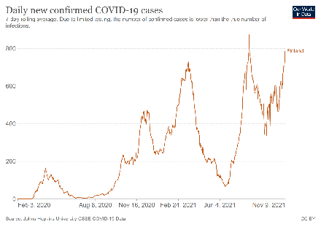  *786 new cases recorded on 09.11.2021 | Infection rate (cumulated past 14 days): 175 cases per 100.000 inhabitants (stable from 146 cases per 100.000 inhabitants on 8 September 2021)  On 10.11.2021, 76,9% of the population received at least one dose of Covid-19 vaccine and 71,2% have been fully vaccinated.  COVID certificate: the EU Covid Certificate is only used for international travel-related measures and has not used for domestic measures/restrictions.  Bar/restaurant Nightclub Hotel Public transport Cultural events/ gatherings Gym/Sport facilities Shop/shopping mall Personal care services  COVID certificate required? No No No No No No No No  General information: No curfew or restrictions on free movement. The Ministry of Social Affairs and Health has implemented the COVID-19 action plan divides the epidemic into three phases (applied at the regional level): baseline, acceleration phase and community transmission phase. Regions apply diverging restrictions based on the phase determined. Once is achieved sufficient vaccination coverage (80%), this classifying system will be discontinued as stated in the recent The hybrid strategy for managing the COVID-19 crisis and the related action plan.  The use of masks in public transportation and among the public in areas that experienced covid-19 cases within the last 14 days is recommended. Maintaining physical distance of 1-2 metres is recommended. Non-essential shops are open with the following safety measures: limitation of the number of visitors, physical distancing and guidance on personal hygiene. The restrictions and recommendations concerning events, gatherings and meetings differ from one region to another depending on the phase of the epidemic.  Health protocols for domestic tourism are available: Guidelines. Recommended contact tracing app: Koronavilkku.  Regarding Indoor and outdoor meetings, public or private gatherings and events rules differ from one region to another based on the epidemic phase:  Epidemic at a stable level and acceleration phase of the epidemic:  At present, no assembly restriction decisions issued by the regional government agency are in force in any region. Municipalities can decide on restrictions on gatherings in their areas. That said, if needed, there could be restrictions on the number of participants at a regional level, which would limit e.g. customer numbers at the local level as necessary number of persons at public events restricted to half (50 per cent) of the normal capacity  Community transmission phase of the epidemic:  At the regional level, the number of participants at public events may be limited to 10 persons or, if necessary, events may be prohibited altogether.  Hotels are open but many are forced to keep their services closed due to lack of customers as well as financial reasons.  Bars and restaurants: are open across with general restrictions (customers are provided with information and instructions so that they can act correctly and prevent coronavirus infections; customers can wash their hands; there are sufficient distances between customers indoors and outdoors; the restaurant and in particular, all surfaces in it, are kept clean). As an alternative to the COVID-19 restrictions a Covid-19 passport (available in My Kanta Pages) could be required.  Different specific restrictions apply on a regional basis. You can see here the Restrictions listed by region valid from 06.09.2021. Establishments must close at 1:00 (alcohol served until 23:00) in ‘acceleration’ regions and at 23:00 (alcohol served until 22:00) in ‘community transmission’ regions. Both indoors and outdoors, the number of customer seats is restricted to 75% of normal capacity for restaurants serving food and to 50% for businesses that primarily serve alcoholic beverages, in ‘acceleration’ and ‘community transmission’ areas.  Travel restrictions: The EU and Schengen countries are allowed to enter Finland for non-essential reasons. Persons who have received a complete vaccination series may be granted entry into Finland from any country, provided that at least 14 days have passed since the last vaccine dose has been received. A person who has not received a complete covid-19 vaccination series must have an essential reason. Please find more information on travel restrictions here  - Low-risk countries: passengers do not need to undergo any health security measures on entry.  - High-risk countries: passengers who do not have a vaccination certificate or a recovery certificate must present on demand certificates related to COVID-19 disease and/or take a compulsory coronavirus test.
France  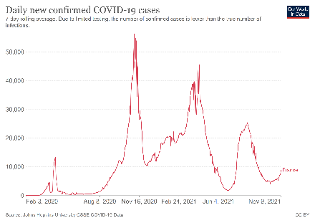  *8830 new cases recorded on 09.11.2021 | Infection rate (cumulated past 14 days): 146 cases per 100.000 inhabitants (down from 332 cases per 100.000 inhabitants on 8 September 2021)  On 10.11.2021, 76,3% of the population received at least one dose of Covid-19 vaccine and 68,6% have been fully vaccinated.  COVID certificate: The “Pass Sanitaire” is necessary to attend all cultural and recreational events, held indoors or outdoors as well as to enter museums, cinemas, cafés, restaurants, shopping centres, hospitals, retirement houses and for long distance-travel by plane, train or bus. The Covid-19 became necessary for people aged 12 to 17 after 30.09.2021.  Bar/restaurant Nightclub Hotel Public transport Cultural events/ gatherings Gym/Sport facilities Shop/shopping mall Personal care services  COVID certificate required? Yes Yes Yes No (only required for long distance-travel) Yes, from 50 people Yes No (only required for stores >20.000 sq. m.) No  General information: The use of masks is not compulsory outdoors but is compulsory in enclosed public places. Facemasks are no longer required in events that require a COVID certificate. A physical distancing of at least 2 metres applies in all places and circumstances. Organisations are putting in place minimum levels of days of working from home. Workers in the public sector must work from home three days a week.  Places of worship are open but require a Covid-19 certificate (Pass Sanitaire) for people attending cultural events. A Covid-19 certificate is not required for religious ceremonies  Gatherings are allowed. Amusement parks, exhibition centres, and sports arenas are open. Cultural establishments, cinemas, theatres and museums are open but require a Covid-19 certificate (Pass Sanitaire) for crowds above 50 people. Gatherings are allowed. Amusement parks, exhibition centres, and sports arenas are open but require a Covid-19 certificate (Pass Sanitaire).  Health protocols for tourism services and tourists. TousAntiCovid is available since 2/6/2020. The App allows the user to be notified of possible close contact (less than 1 metre for at least 15 minutes) with someone who has then been tested positive to Covid. "  Hotels have reopen to their guests as well as their catering facilities.  Bars and restaurants: Restaurants, bars and cafés are open both for indoor and outdoor service (terraces). Access to these facilities (including for service in terrace) requires a Covid-19 certificate. Nightclubs reopened. There is a maximum of 10 people per table, 2 metre between each table  Travel restrictions: Vaccinated passengers can travel to France with no restrictions linked to health conditions. Non-vaccinated passengers are subject to health conditions according to the country they are from (see colour code).  - Green countries: each traveller must present a negative PCR or antigenic test or a recovery certificate before the flight. All EU/EEA countries are considered as green countries.  - Orange countries: travellers can only travel to France if you have pressing grounds for travel. Each traveller must present a negative PCR or antigenic test or a recovery certificate before the flight. You may be subject to a random test when you arrive in France. You must pledge to self-isolate for 7 days.  - Red countries: travellers can only travel to France if you have pressing grounds for travel. Each traveller must present a negative PCR or antigenic test or a recovery certificate before the flight. You will be tested when you arrive in France. You will be subject to a mandatory 10-day quarantine supervised by security forces.  To take the plane, non-vaccinated people should carry a sworn declaration, an exempted international travel certificate and a proof of location of self-isolation.  Please find more information on travel restrictions here.
Georgia  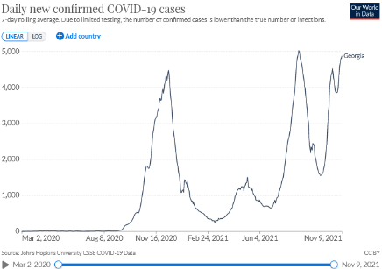  * 4875 new cases recorded on 09.11.2021 | Infection rate (cumulated past 14 days): 1561 cases per 100.000 inhabitants (up from 1067 cases per 100.000 inhabitants on 8 September 2021)  On 09.11.2021, 26,7% of the population received at least one dose of Covid-19 vaccine and 24,1% have been fully vaccinated.  General information: the Government of Georgia has imposed some new measures in an effort to curtail the COVID-19 pandemic, including but not limited to a mask mandate while outdoors, a ban on large social and entertainment events, closure of restaurants from 11pm to 5am, closure of nightclubs and campgrounds. Public transport and taxis are operating. The Government of Georgia posts updates here.  It is mandatory to wear masks inside shops, hotels, restaurants and transports. However, are no longer mandatory outdoors. Enforcement of regulations on social distancing remains in place. Social distancing requirements remain in place. Large celebratory gatherings such as weddings remain banned.  Open and closed markets in all cities of the country continue operating. Museums, gyms and, to a limited extend, theatres have re-opened. Businesses, including shopping malls and open-air markets, must continue to operate with and certain sanitation rules to keep customers and employees safe.  Hotels: Most hotels and other rental accommodation are open. Face masks must be worn when entering public spaces inside hotels and rental accommodation.  Bars and restaurants: Restaurants and bars are open but restaurants (including those in hotels) can only serve customers until 11pm. Food services from 10pm to 5am are take-away/delivery only. Clubs remain closed.  Travel restrictions: Unvaccinated travellers should complete an application form prior to arrival with contact details and travel history.  Arrival by air:  - Fully vaccinated foreign citizens arriving by air may be unconditionally admitted to Georgia.  - Non-vaccinated foreigners is allowed for this list of countries if they present a negative PCR test result and a follow-up PCR test at their own expense on the third day after arrival in Georgia.  Arrival by land or sea:  - Travelers arriving by land or sea from the listed countries and travel must be directly from a listed country (including Armenia, Azerbaijan, and Turkey), including transit through third countries.  - Vaccinated travelers must present BOTH proof of vaccination and a negative PCR test result. No follow-up PCR test is required.  - Unvaccinated travelers is allowed for this list of countries if they present a negative PCR test result and a follow-up PCR test at their own expense on the third day after arrival in Georgia.
Germany  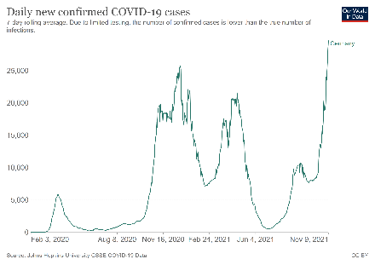  *29642 new cases recorded on 09.11.2021 | Infection rate (cumulated past 14 days): 405 cases per 100.000 inhabitants (up from 167 cases per 100.000 inhabitants on 8 September 2021)  On 10.11.2021, 69,7% of the population received at least one dose of Covid-19 vaccine and 67,1% have been fully vaccinated.  COVID certificate: A nationwide “3G rule” is in effect that requires either proof of vaccination, proof of recovery from the virus or a negative test (a rapid antigen test taken within 24 hours or a PCR test taken within 48 hours) to access many indoor facilities. Federal states can decide to relax these restrictions in districts with a low number of infections (7-day incidence below 35 per 100,000 inhabitants). Specific regulations for each federal state are available here.  Bar/restaurant Nightclub Hotel Public transport Cultural events/ gatherings Gym/Sport facilities Shop/shopping mall Personal care services  COVID certificate required? Yes Yes Yes No Yes Yes No Yes  General information: cases have soared during the first week of November, reaching an infection number of 201 per 100.000 people, the highest figure since the start of the pandemic. Consequently, federal authorities have started to implement stricter measures. Saxony and neighbouring Thuringia are currently the two states with the highest incidence of cases, more than double the national average. They are also the states with the lowest rates of vaccination.  Specific regulations for each federal state are available at the Federal Tourism Competence Centre. Local authorities can impose stricter rules in high infection rate areas. If there is a seven-day incidence of over 100 new infections / 100,000 inhabitants on three consecutive days, the federal emergency brake comes into force. In that case, a curfew applies at night from 10:00 pm to 5:00 am.  ‘Medical grade’ facemasks should be used in public closed spaces for all citizens above 6 years old, as well as masks outside shops where queues are formed and in car parks. Personal contacts between households must kept to a minimum; each federal state can set specific rules for the maximum number of people that are allowed to meet together, with different limits applicable to indoor and outdoor spaces.  Fully vaccinated persons and symptom-free recovered persons are exempt from the obligation to test, the curfew and the contact restrictions. In private get-togethers and similar social contacts in which vaccinated or recovered persons as well as other persons take part, vaccinated and recovered persons are not taken into account when determining the number of participants. In shops, they will be treated the same as people who have tested negative. Events with from 500 people to 1500 people are permitted, according to the region and the incidence level.  Grocery stores and shops to meet daily needs are open. In areas where the infection rate is between 50 and 100 infections per 100 000 inhabitants in seven days, non-essential shops are allowed to open, although under strict conditions (reserved time slot). The situation of retail stores depends on the region and on the number of infections, as explained above.  Recommended contact tracing app: Corona-Warn-App  Hotels: Hotel stays for touristic purposes are open, subject to the 3G rule. Details on restrictions in the federal states are available on the tourism guide.  Bars and restaurants: Restaurants, bars and cafés are open to the public subject to the 3G rule. Details on current restrictions in the federal states are available on the tourism guide. Nightclubs are allowed to reopen in some areas subject to the 3G rule and submission of a ‘hygiene concept’.  Travel restrictions: Germany classifies areas as: "high incidence" or "virus variant", areas. On November 7 this list was updated. All travellers entering Germany have to provide a negative test result, proof of full vaccination, or proof of recovery, independent from where they arrive. Travellers entering Germany, who have been in a risk area at any time within the last 10 days before entry, are obliged to register. Please find more information on travel restrictions here.  - High-incidence areas: Travellers who come from a high-incidence area must self-isolate until they submit to the digital registration on entry either a proof of vaccination, a proof of recovery or a pre-departure negative PCR test.  - Virus variant areas: Travellers who - in the last 10 days - have stayed in an area of variant of concern are subject to a pre-departure negative PCR test taken within 72 hours prior to arrival (or a rapid antigen test taken within 24 hours prior to arrival) and must self-isolate for 14 days after arrival.
Greece  *6679 new cases recorded on 09.11.2021 | Infection rate (cumulated past 14 days): 738 cases per 100.000 inhabitants (up from 380 cases per 100.000 inhabitants on 8 September 2021)  On 10.11.2021, 62,4% of the population received at least one dose of Covid-19 vaccine and 59,9% have been fully vaccinated.  COVID certificate: The Greek Covid Pass app is designed to check customers' "safe" status and verifies whether an individual has been vaccinated, recovered from COVID or has recent negative PCR or antigen test results. The Greek government has a separate scheme - the Freedom Pass - designed to encourage 18 - 25 years olds to get vaccinated.  Bar/restaurant Nightclub Hotel Public transport Cultural events/ gatherings Gym/Sport facilities Shop/shopping mall Personal care services  COVID certificate required? Yes (indoors) Yes No No Yes (indoors) No No No  General information: COVID-19 infections in Greece hit a new daily high almost every day in November, prompting authorities to announce new measures, which also restrict access to cafes and restaurants, state services and banks to those who are either vaccinated or have a negative test. There are four (4) levels of risk, depending on the epidemiological situation at each region or municipality, varying from 1 (low risk) to 4 (high risk). Specific protection measures can be applied to areas of the country classified as level 3 and level 4. The map is updated weekly and can be consulted here. Travel to Greek Islands is subject to presentation of proof of vaccination, recovery or a negative test.  The use of facemasks is mandatory both indoors and outdoors. Gatherings with 4 or more people are not allowed. Individual sport with a maximum number of three people is allowed. Special social distancing rules have been set for a wide range of places. Museums are open, but with capacity restrictions. Live events (theatre or dance performances, concerts etc.) are held in open-air venues with seated guests only and at 65% - 75% capacity, depending on the size of each venue. Indoor venues are held at up to 85% capacity. Shops are fully open.  Hotels: are open. Safety protocols for tourism services. Tourist accommodation establishment managers are required to create an action plan, to have a health protocol in place for each part of the establishment and be ready to deal with a potential Covid-19 case, in accordance with the current guidelines of the National Public Health Organisation (e.g., hotel quarantine area).  Bars and restaurants: are open to seated customers only. Until 31 March 2022, indoor catering spaces (including night clubs) will only allow visitors that can show an official certificate of vaccination, or certificate of recovery (no older than 6 months). Indoor spaces have limited capacity. Up to 10 individuals are allowed per table. Two customers seated on stools are allowed at the counter and a 1.5 m distance must be kept from the next two customers.  Travel restrictions: All travellers must complete their PLF before entering the country. Click here to see which countries are allowed to enter Greece under the following conditions and without a self-isolation. All travellers arriving in Greece are required to have either a negative PCR certificate or a negative antigen (rapid) certificate regardless of the epidemiological situation in the country of departure except for fully vaccinated travellers and travellers who recovered from the COVID.
Hungary  *5441 new cases recorded on 09.11.2021 | Infection rate (cumulated past 14 days): 647 cases per 100.000 inhabitants (up from 26 cases per 100.000 inhabitants on 8 September 2021)  On 10.11.2021, 60,6% of the population received at least one dose of Covid-19 vaccine and 58,5% of the population is fully vaccinated against Covid-19.  COVID certificate: “Persons protected against the coronavirus” means persons holding an immunity certificate issued by the relevant Hungarian authority. It also means persons holding an immunity certificate issued by a state whose immunity certificate is recognized by Hungary.  Bar/restaurant Nightclub Hotel Public transport Cultural events/ gatherings Gym/Sport facilities Shop/shopping mall Personal care services  COVID certificate required? No Yes (if after 2am) No No Yes (indoor or >500 people) Yes (indoor or >500 people) No No  General information: there is no curfew in place or internal travel restrictions.  As of November 1, 2021, masks are required on public transport. Masks are still required in medical facilities. No minimum distance is required outdoors and indoors.  Up to 100 people can attend family and private events. Sport is free in public spaces. Indoor sport and cultural events or outdoor events with over 500 people can only be attended by people with immunity certificate. Maximum 400 people can attend at weddings. Indoor other events (ex. conferences) and concerts: only “Persons protected against the coronavirus” can attend. Stores are open. It’s possible to enter even without immunity certificate.  Museums, libraries, cinemas, zoos and similar leisure facilities are open to “Persons protected against the coronavirus”. Stores are open. All services are open, such as hairdressing salons​, beauty salons​, and other services under certain safety and hygiene measures.  Guidelines available for tourism services: The Covid manual of the Hungarian Tourism Agency and Recommendations for reopening restaurant terraces and gardens.  Hotels: Tourism accommodations are open to all guests. Entry into hotels, stores, restaurants, baths and water parks is possible without an immunity certificate.  Restaurants and bars: are open and there are no restrictions in place for guests. Proof of vaccination required for most clubs open past 2am with no restrictions. No proof of vaccination for any venue closing before 2am. No mask required.  Travel restrictions: There are no restrictions at land borders and no restrictions for travellers holding an EU Digital Covid Pass or with certificate of vaccination, recovery or negative PCR test taken within 72 hours from the time of entry.  Special measures apply to travels not falling into the general exemption categories, based on their citizenship and purpose of their stay. Hungarian citizens are allowed to enter Hungary (no need for entry permit or PCR test) regardless of the purpose of stay, but they must go into isolation for 10 days, or until they can present two negative PCR tests performed two days apart. Non-Hungarian citizens can enter Hungary only in exceptional cases depending on the purpose of stay and must receive an entry permit from the Hungarian police.  Please find more information on travel restrictions here.
Iceland  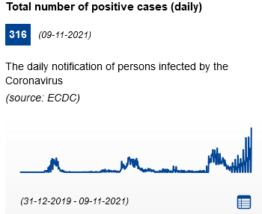 | Infection rate (cumulated past 14 days): 443 cases per 100.000 inhabitants (up from 243 cases per 100.000 inhabitants on 8 September 2021)  On 09.11.2021, 82,5% of the population received at least one dose of Covid-19 vaccine and 81,3% have been fully vaccinated.  COVID certificate:  Bar/restaurant Nightclub Hotel Public transport Cultural events/ gatherings Gym/Sport facilities Shop/shopping mall Personal care services  COVID certificate required? No No No No No No No No  General information: following the Ministry of Health decision, stricter domestic measures have been taken due to the proliferation of infections.  Masks will be required when the one-metre social distancing rule cannot be observed, the maximum number of persons allowed in the same location will be 500. Events with up to 1500 participants will be allowed subject to rapid tests. The Minister of Health has decided to take these measures in keeping with the recommendation of the Chief Epidemiologist, who has expressed concern over the rapid increase in infections, the increase in serious illness and the growing strain on the health care system. The requirement to wear a mask entered into force November 5, and the other changes apply as of Wednesday, 10 November, and will remain in force for four weeks, until Tuesday 8 December.  Performing arts, cinema theatres and other cultural events may have up to 2000 persons on stage, i.e. during rehearsals and shows. Up to 2000 seated guests may be accommodated. Museums may receive 100% of the maximum number of visitors allowed, but not more than 2000. Spas and gyms are open for a maximum permitted number of people.  Pharmacies, grocery stores and other stores may have up to 2000 customers in their premises, as long as it is possible to ensure at least a distance of 1 metre between persons who are unrelated.  Hotels: are open without restrictions. Camping grounds and caravan sites can accommodate 2000 persons in each infection prevention area.  Restaurants and bars: where alcoholic beverages are allowed, may not stay open longer than 23:00 all days of the week with a maximum of 2000 guests in each area and must maintain the 1-metre distance rule. The opening time will be reduced by two hours; closing time will be 23:00h (11 p.m.) and the venues must be vacated before midnight. Registration of guests will begin again, and alcohol shall be served at the table (applies as of 10 November).  Travel restrictions: Iceland adopts its own national classification of risk areas. All countries and territories of the world, except Greenland, are currently classified as risk areas. Travel restrictions apply to all third-country citizens (individuals who are neither citizens of EEA/EFTA states nor citizens of Andorra, Monaco, San Marion or the Vatican), irrespective of whether the traveller needs a visa or can travel without a visa to the Schengen areaAll passengers born before 2005 are required to fill out a pre-registration form before departure to Iceland.  - Starting 1 October, all travellers who enter Iceland, and are considered to have close ties within the Icelandic community, will only need to undergo a COVID-19 test after arrival in Iceland and don't need to present a negative result prior to boarding. They are not required to quarantine, but are asked to limit their interactions in the first few days after arrival.  - If travellers don’t have any vaccination certificate or a certification that proves a previous COVID-19 infection or have a certificate that is not valid, they need to present a negative PCR test certificate against COVID-19. Rapid antigen tests are in this case not considered valid.  Please find more information on travel restrictions here.
Ireland  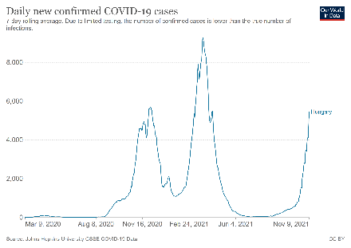  *3672 new cases recorded on 09.11.2021 | Infection rate (cumulated past 14 days): 882 cases per 100.000 inhabitants (up from 434 cases per 100.000 inhabitants on 8 September 2021)  On 10.11.2021, 77,1% of the population received at least one dose of Covid-19 vaccine and 75,8% have been fully vaccinated.  COVID certificate: The Covid Digital Certificate became operational on 19.07.2021. It delivers proof of vaccination, recovery or a negative test (valid 72 hours). Over two million certificates were issued within the first few weeks of launch.  Bar/restaurant Nightclub Hotel Public transport Cultural events/ gatherings Gym/Sport facilities Shop/shopping mall Personal care services  COVID certificate required? Yes (indoors) Yes No No Yes No No No  General information: Resilience and Recovery 2021: The Path Ahead is a revised plan for living with COVID-19. People are allowed to travel outside their own county. It is mandatory to work from home when possible. Return to workplaces will continue on a phased and cautious basis for specific business requirements  According to the last update of this plan (October 28) nightclubs and music venues are now effectively able to operate at full capacity having been closed for nearly 600 days. Live music venues can allow up to 1,500 people standing at events, in addition to full seating capacity. There is limit of 6 for mixed immunity groups in gyms, pools and leisure facilities. However, there is no capacity limit for vaccinated groups. Public transport returns to full capacity and coach tours are permitted with 75% capacity – wearing a mask in transport is compulsory. There are no restrictions for domestic travel. Business events/conferences can take place once all participants show Proof of Immunity. Organised outdoor events & mass gatherings are permitted with appropriate protective measures  For those working in the tourism sector, Fáilte Ireland (National Tourism Development Authority) has published a set of operational guidelines for businesses to assist them reopen safely. COVID Tracker can be downloaded at www.gov.ie  Hotels: reopened but services are restricted to overnight guests and residents only.  Bars and restaurants Organised indoor events and mass gatherings are permitted where all patrons are immune (fully vaccinated or recovered from COVID-19 within previous 6 months), or accompanied minors (under 18). Outdoor Hospitality can continue to operate for customers who are unable to provide evidence of COVID-19 vaccination or immunity following recovery. A maximum of 15 people including no more than 10 adults may be seated at a table. All indoor events concerning Live Entertainment and Nightclubs must be ticketed electronically –and the ticket must be purchased or acquired at least one hour before attendance at the event.  Travel restrictions: All passengers travelling to Ireland must fill out a COVID-19 Passenger Locator Form before departure, and have a valid proof of vaccination (like the EU Digital Covid certificate) or recovery, or to present evidence of a negative RT-PCR result from a test taken within 72 hours prior to arrival into the country. Non RT-PCR tests are not accepted when travelling to Ireland and passengers with a Digital COVID Certificate based on a non RT-PCR test (for example, antigen tests) require proof of an additional negative RT-PCR test taken no more than 72 hours before arrival.  More information can be found here.
Italy  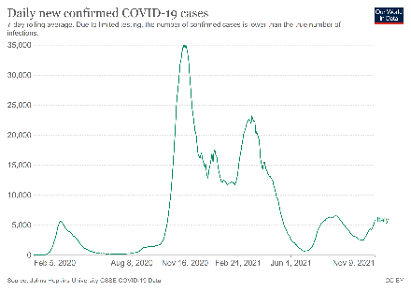  *5870 new cases recorded on 09.11.2021 | Infection rate (cumulated past 14 days): 117 cases per 100.000 inhabitants (down from 146 cases per 100.000 inhabitants on 8 September 2021)  On 10.11.2021, 77.9% the population received at least one dose of Covid-19 vaccine and 72,1% of the population is fully vaccinated.  COVID certificate: In both ‘white’ and ‘yellow’ regions, to access specific indoor public places, events and gatherings, people are requested to hold the EU Digital COVID certificate or a certification of at least one dose of vaccine or have tested negative for a molecular or antigenic test in the previous 48 hours or have been recovered from COVID-19 in the previous six months  Bar/restaurant Nightclub Hotel Public transport Cultural events/ gatherings Gym/Sport facilities Shop/shopping mall Personal care services  COVID certificate required? Yes (indoors) / No (except non-staying guests) Yes (except local transport) Yes Yes No No  General measures: The state of emergency has been prolonged until 31.12.2021. Restrictive measures vary according to the epidemiological level of each Italian Region. The subdivision of the national territory in four main areas, corresponding to four risk scenarios, for which modular measures are envisaged: white (low risk), yellow (medium risk), orange (high risk) or red (very high risk). All Italian regions are currently classified as “white”. There is no curfew or limitation of movement in effect in “white” areas. From 26 April, Italian residents who have received a 'green pass', including for tourism, are be able to move throughout Italian territory. Everyone over 12 years of age must show the EU COVID-19 digital certificate to attend to catering establishments, non-local transport, shows, museums, cinemas, institutions, swimming pools, discos, etc. In all (white) regions, cultural venues (museums, cinemas, theatres, concert halls) are allowed to work to full capacity; sporting events are limited to 75%; and night clubs are limited to 75% outdoors and 50% indoors.  It is mandatory to wear a facemask in closed spaces, including means of transport, and outdoors when social distancing is not guaranteed, from 6 years old, with the exception of places where the condition of isolation from other people is guaranteed. Physical distancing of 1 meter (2 meters for sports activities).  In ‘white’ regions indoor and outdoor meetings, public or private gatherings and events are allowed, applying limitations on number of people and social distancing according to the type of events. Events open to the public in theatres, concert halls, cinemas and other venues or spaces are allowed. Retail activities are open.  In all regions, shops are open and must display a sign indicating the maximum number of people allowed inside at any particular time. Shopping centres may also remain open at weekends and on holidays and pre-holidays. Measures on social distance and the use of facemask remain in place.  Covid-19 updates: information for tourists (italia.it). Recommended contact tracing app: https://www.immuni.italia.it/  Hotels: In all the regions, the activities of accommodation facilities allowed, provided that strict hygiene measures are in place. Catering in hotels and other accommodation facilities is allowed without time limits, exclusively to its customers. If the catering services of the accommodation are also open to customers who do not stay in the structure, the access will be reserved only to those who – customers of the structure or external customers – have the EU digital COVID certificate, in case of consumption at the table indoors. Guidelines for accommodation  Restaurants and bars: In “White” areas, both outdoor and indoor, catering is allowed without time limitations and without guest limit on each table. In ‘yellow’ regions, there is no limit to the number of people who may sit at the same outdoor table and up to a maximum of 6 non-cohabiting people may sit together indoors; there are no limits to the number of people for 2 families who decide to dine together at the same table. Find out more one Guidelines for restaurants.  Travel restrictions: Italy adopts its own national classification of risk areas and applies restriction measures depending to incoming travellers depending on their country of origin. All persons travelling to Italy from any foreign location are required to fill out the EU Digital Passenger Locator Form.  - List A – Vatican City and Republic of San Marino: there is no requirements.  - List B – there are no states in this category.  - List C – corresponds to the EEA/EFTA states. Free movement is allowed to and from these countries for any reason, therefore also for tourism. The only requirement is to provide a Covid certificate, having recovered from Covid-19, or having taken a PCR or antigen test prior entering Italy. Failure to submit one of these documents entails self-isolation at the address indicated on the Passenger Locator Form for 5 days, at the end of which an antigen or molecular swab test will be carried out.  - List D – corresponds to Saudi Arabia, Australia, Bahrain, Canada, Chile, United Arab Emirates, Japan, Jordan, Kosovo, Israel, Kuwait, New Zealand, Qatar, Rwanda, United Kingdom of Great Britain and Northern Ireland, Republic of Korea, Singapore, United States of America, Ukraine, Uruguay, Taiwan, Hong Kong and Macao Special Administrative Regions and the States. Coming from these territories it is needed to comply with all the requisites of list C, and, to self-isolate 5 days on arrival (if this has not been done before departing).  - List E – rest of the world. Entry is allowed only for specific reasons and it is require to undergo 10 days of self-isolation on arrival.
Latvia  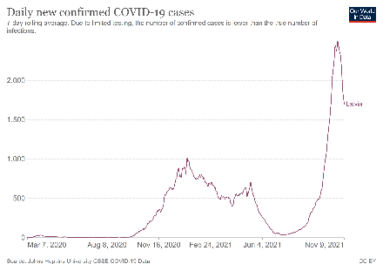  *1700 new cases recorded on 09.11.2021 | Infection rate (cumulated past 14 days): 1506 cases per 100.000 inhabitants (up from 182 cases per 100.000 inhabitants in on 8 September 2021)  On 10.11.2021, 60,5% of the population received at least one dose of Covid-19 vaccine and 53,6% of the population is fully vaccinated.  COVID certificate: Public events, demonstrations or meetings are not held. Private events can take place within one household at the place of residence. Catering is only possible to provide food for pick-up or delivery. Catering establishments can be opened 24h a day for this purpose.  Bar/restaurant Nightclub Hotel Public transport Cultural events/ gatherings Gym/Sport facilities Shop/shopping mall Personal care services  COVID certificate required? - - No No - - No No  General information: All the measures that are currently in place in Latvia can be found at Covid-19 control measures. From 21 October to 14 November 2021, particularly strict safety arrangements have been introduced in Latvia, including curfew from 20:00 to 5:00. Work takes place remotely. There is a shortage of health care services. Due to insufficient resources, mainly human resources, a state of emergency has been declared in medicine.  Urban public transport cannot exceed 50% of its capacity. The capacity of regional and interurban public transport is up to 80%. Sports training can only be done individually or one household and sports training services is not allowed. Education and university is functioning primarily online. Cultural sites and events cannot operated. Stores and shopping centres can only open from 6:00 to 19:00, with no less than 25 sq.m. per customer of retail space.  In indoor spaces outside the household, a face mask must be worn if there is more than one person in the room. It is also mandatory in public transport and in educational institutions. People must respect 2 metres physical distancing. People vaccinated against Covid-19 or who have recovered from it are exempted from wearing the mask and keeping the social distance in some situations. Persons who are vaccinated, recovered from Covid-19, or teste are allowed to gather indoors for up to 500 people, outdoors for up to 1000 people. Persons that are not vaccinated, recovered from Covid-19, or tested are allowed to gather indoors for up to 20 people and are allowed to gather outdoors for up to 50 people (also marches and pickets follow this category)  Contact tracing app: Apturi  Hotels can stay open on the condition that physical distancing and epidemiological safety measures are being followed. By complying with recommendations, including disinfection of surfaces and others, hotels and guest houses can operate and admit guests.  Restaurants: can work around the clock to provide food for pick-up or delivery. At least 15 sq.m. per person must be provided indoors at the place of receiving the service.  Travel restrictions: All travellers must fill in an electronic confirmation form at Covidpass.lv. Travellers can enter Latvia without being subject to additional restrictions if their EUDCC contains either a vaccination certificate, a recovery certificate or a negative Covid-19 test result. More information on entry restrictions and security measures here: Overview of entry restrictions and security measures | Covid-19 (covid19.gov.lv)  - Unessential travel from a very high-risk countries is not allowed.  - Unessential entry from a high-risk countries is allowed only for vaccinated/recovered persons.  - Persons entering Latvia by land who do not possess an inter-operational EU certificate of vaccination, testing or recovery, must immediately take a COVID-19 test at their own expense.  - Those without a covid certificate coming from a high or very high risk country must self-isolate for 10 days which may be shortened to 7 with a negative test.
Liechtenstein  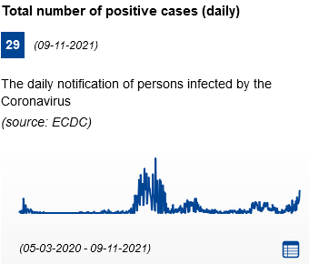 | Infection rate (cumulated past 14 days): 356 cases per 100.000 inhabitants (up from 284 cases per 100.000 inhabitants on 8 September 2021)  On 09.11.2021, 66,3% the population received at least one dose of Covid-19 vaccine and 64,6% of the population is fully vaccinated.  COVID certificate: The distance requirement can be relaxed in the case of events requiring a COVID certificate from all participants.  Bar/restaurant Nightclub Hotel Public transport Cultural events/ gatherings Gym/Sport facilities Shop/shopping mall Personal care services  COVID certificate required? No No No No No No No No  General information: General measures are available at https://medienportal.regierung.li/Medienmitteilungen/Detail/228133. People can travel freely within the country. People are no longer required to wear masks except on public transportation.  Events are allowed as long as organisers have implemented measures to protect participants, in particular to ensure the minimum distance of 1.5 Meters. The distance requirement can be relaxed in the case of events requiring a COVID certificate from all participants proving vaccination, test or recovery. No limitations regarding number of participants for private events with friends and relatives. Non-essential shops and personal care services are open.  Health safety protocols for hotels and restaurants are available on the website www.lhgv.li.  Hotels are open in compliance with hygiene and safety guidelines. Restaurant operations for hotel guests must be based on a protection concept. There is an obligation to wear a mask based on the hygiene regulations.  Bars and restaurants: In catering establishments there are no limits any more for the number of guests in one group. Distance between groups hast to be ensured. No obligation for guest to sit down.  Travel restrictions: same rules as in Switzerland are applicable.  - Holders of ‘EU Digital COVID Certificates’ (EUDCC): it is allowed to enter Liechtenstein from countries without a variant of concern without being subject to additional restriction if their certificate contains either a vaccination certificate, a recovery certificate or a negative Covid-19 test result.  - Non-Holders of ‘EU Digital COVID Certificates’ (EUDCC): Entering by car/coach/train is allowed when travelling from a country or area without a variant of concern without any further pandemic-related measures and without the test and quarantine requirement.  - Non-Holders of ‘EU Digital COVID Certificates’ (EUDCC): Entering by air, travellers who are not fully vaccinated or unable to prove that they have recovered from COVID-19 will have to present proof of a negative PCR test or rapid antigen test.
Lithuania  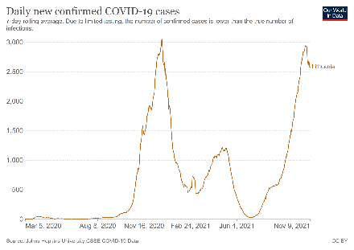  *2583 new cases recorded on 09.11.2021 | Infection rate (cumulated past 14 days): 1428 cases per 100.000 inhabitants (up from 322 cases per 100.000 inhabitants on 8 September 2021)  On 09.09.2021, 64,8% of the population received at least one dose of Covid-19 vaccine and 61,5% of the population is fully vaccinated.  COVID certificate: A National Covid Certificate entered into effect on 24.05.2021, available for citizens who have been vaccinated, tested or can demonstrate immunity, as well as under 16s. Holders of the national certificate are generally exposed to less restrictions upon presentation of the certificate.  Bar/restaurant Nightclub Hotel Public transport Cultural events/ gatherings Gym/Sport facilities Shop/shopping mall Personal care services  COVID certificate required? Yes Partially No No Yes (indoors) No No No  General information: Movement within the country is free, no curfews or movement restrictions are imposed. All public and private sector employees can return to their workplace.  As of 13 September, all contact services and economic activities shall be carried out and events organised (except for the established exceptions) only for persons who meet the criteria set by the National Certificate. In case the indoor event is organised for less than 500 spectators, face masks are recommended for the holders and mandatory for non-holders of National Certificate. In case the event is organised for more than 500 spectators, face masks are mandatory for the holders National Certificate. Non-holders of national Certificate are not allowed to enter events with more than 500 spectators. All stores, marketplaces and other public points of sale are open. All stores, marketplaces and other public points of sale are open. Non-holders of National Certificate are not allowed to enter non-essential shops and all type of shops with areas larger than 1500 sq.m.  Recommended contact tracing app: Korona Stop LT  Hotels: All tourist accommodations are open.  Bars and restaurants: Restaurants, cafes and bars are open only for holders of National Certificate without limitations. Non-holders of National Certificate are not allowed to enter catering establishment Face masks are mandatory in indoors shared spaces. Night clubs, discos and other dancing venues resumed their activities.  Travel restrictions: Every traveller arriving in Lithuania will have to fill in a form on the website of the National Public Health Centre. EUDCCs are valid to enter Lithuania if they contain either a vaccination certificate, a recovery certificate or a negative Covid-19 test result.  - "yellow": Travellers have to take a second PCR test after arrival (unless they are vaccinated or have recovered from Covid-19).  - Risk areas (all areas other than "green" or "yellow"): Unless they can provide proof of full vaccination or recent recovery from Covid-19, travellers are also subject to mandatory self-isolation for 10 days from the day of arrival. The isolation period may be shortened after a second negative PCR test performed no earlier than on day 7 of self-isolation.  - Non-holders of a certificate must present proof of vaccination, recovery, or submit a pre-departure negative test result. Accepted tests: PCR taken within 72 hours prior to arrival or rapid antigen test (RAT) taken within 48 hours prior to arrival.
Luxembourg  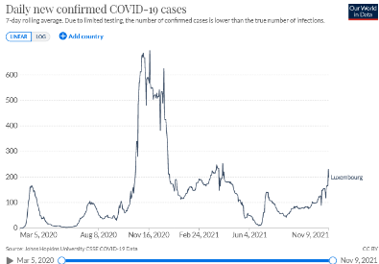  *198 new cases recorded on 09.11.2021 | Infection rate (cumulated past 14 days): 371 cases per 100.000 inhabitants (up from 178 cases per 100.000 inhabitants on 8 September 2021)  On 09.11.2021, 70,1% of the population received at least one dose of Covid-19 vaccine and 65,9% of the population is fully vaccinated.  COVID certificate: A voluntary CovidCheck system has been put in place allowing private individuals, businesses (restaurants, bars, shops, fitness centres) and public and private venues to host events restricted to people who are vaccinated, recovered from COVID-19 or who present a negative test (certified or the result of auto tests performed locally prior to entry (not valid for venues hosting people between 1 and 6 am)).  Bar/restaurant Nightclub Hotel Public transport Cultural events/ gatherings Gym/Sport facilities Shop/shopping mall Personal care services  COVID certificate required? Yes Yes No No Yes (optional) No No No  General information : An overview of the current measures is available in French, English, German and Luxembourgish on the website Covid-19.lu.  Wearing a facemask is mandatory in case of indoor activities open to the public as well as on public transport. Social distancing of 2 meters if more than 10 people are present. In addition to the obligation of wearing a mask and maintaining a physical distance of at least 2 metres, the assignment of seats is compulsory for gatherings involving between 51 and 2000 people. Any gathering exceeding 2,000 people is prohibited.  Private gatherings at home or during private events, in a closed or open-air venue, are subjected to the same rules as gatherings. Public gatherings exceeding 300 people are prohibited. Any gathering from 11 up to 50 people is subject to the condition that the people wear masks and observe a minimum distance of 2 metres. And for 51 or more people, the obligation of assigned seats applies. Private gatherings at home can be organised under the CovidCheck system with prior notification. In this case, the system must be notified for gatherings, but does not need to be visibly displayed. Sports activities carried out individually or with a maximum of 10 people are allowed. Sports activities carried out in groups of more than 10 people may be practised, provided that there is a physical distance of at least 2 metres between the different sports participants or that a mask is worn  Non-essential shops and personal care services are open. Institutions of the cultural sector (including theatres, cinemas, museums and libraries) are open to the public. As for other leisure activities, the law no longer specifies any special provisions relating to recreational activities. Hence, the general rules relating to gatherings apply. Wellness-related activities (spa, wellness centres, etc.) as well as physical exercise facilities (such as gyms and fitness centres) are open.  Health protocols for tourism services and tourists (in English).  Hotels: Hotels and other accommodation facilities are open. Since 13 June 2021, catering services provided in hotels are subject to the same rules as those applied for restaurants, bars and cafés (see below).  Bars and restaurants: Restaurants, bars and cafés are open to the public both indoors and outdoors. Inside catering establishments and bars, the CovidCheck system is compulsory. Customers and all staff in these establishments must comply with the obligations under the system and present either a vaccination certificate, a certificate of recovery or a COVID test certificate showing a negative result. Outside areas of restaurants, cafés or bars are not automatically subject to the CovidCheck system. However, the operator of one of these establishments may opt for the aforementioned system to be applied on the outside area.  Travel restrictions: Luxembourg is accepting "EU Digital COVID certificates" (EUDCC). Citizens from the Schengen area are free to enter regardless of their purpose if their certificate contains either a vaccination certificate, a recovery certificate or a negative Covid-19 test result. Third-country nationals may no longer enter the territory of the Grand Duchy until 31 December 2021 (inclusive), except from certain countries.  Click here to see the list of exceptions.
Malta  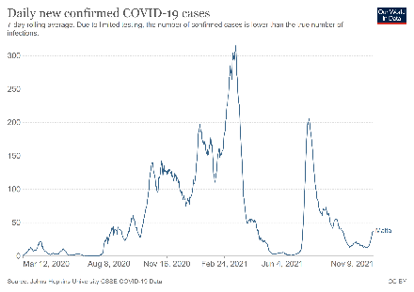  *37 new cases recorded on 09.11.2021 | Infection rate (cumulated past 14 days): 74 cases per 100.000 inhabitants (down from 136 cases per 100.000 inhabitants on 8 September 2021)  On 10.11.2021, 82,2% of the population received at least one dose of Covid-19 vaccine and 81,2% of the population is fully vaccinated.  COVID certificate:  Bar/restaurant Nightclub Hotel Public transport Cultural events/ gatherings Gym/Sport facilities Shop/shopping mall Personal care services  COVID certificate required? Yes No No No Yes No No No  General information: Various standards have been developed for hospitality establishments, cultural and sports venues, events and transport.  The use of face masks is obligatory in all indoor and outdoor public places for people above the age of 3. In outdoor spaces removal of masks is only permitted for vaccinated persons in groups of no more than 2. The use of masks on beaches and at pools is not mandatory. Regarding public transport, the maximum number of passengers shall be 80% of capacity.  All events, (cultural, artistic, dance, theatre, music performances; corporate events - conferences, awards nights; fairs, markets, and exhibitions; Weddings and other celebrations; sports events) have a capping of 500 persons. They are subject to inspection by authorised officers and shall have an identified organiser which has to apply for approval to organise said event. In seated events there must be 2 metres of distance from person to person and no more than 4 person can be seated together (6 if they are from the same household). No more than 8 persons can be seated around a table. If the event has less than 300 persons these limits do not exist. Standing events are limited to 100 participants and not less than 1 person per 2 meters. See more here: Standards for Safer Events in Enclosed Areas​​​​  Non-essential and non-essential services shops are open. The maximum capacity at any time shall be one person per 4m2 including staff. Cultural events and open-air cinemas are open. In cinemas, no more than 6 persons should be allowed to sit together in a group unless they belong to the same household. Contact tracings app: COVIDAlert.  Hotels are open. Standards for hotels and similar establishments.  Bars and restaurants : admittance is exclusive for those with a valid vaccination certificate. Masks are to be worn at all times and can only be removed when eating and drinking. For establishments with a capping of 300 persons, table set up can be in accordance with pre-COVID distances, with no limit to number of persons on tables. Establishments can operate freely until 3:00h. See more here: Standards for Commercial Establishments  Travel restrictions: Malta adopts its own national classification of risk areas. All passengers are required to present a completed Public Health Travel Declaration and Passenger Locator Form link​ (PLF).Malta restricts entry, accepting only holders of vaccination certificates (including EU Digital COVID Certificates) indicating full vaccination with an EU-approved vaccine. Tourists can only travel to Malta if they have a vaccination certificate for two doses of EMA-approved vaccines, and issued after 14 days from the date of the second dose. Recovery certificates are not considered as valid for entering the territory. If any passenger arriving in Malta is not in possession of a recognised vaccination certificate, the passenger will be subject to a mandatory 14 day quarantine in an accommodation provided by the Health Authorities against a fee of 100 per night.  For non-holders of a pass, entry restrictions depend on whether the traveller is coming from a Red country or a dark red country. Tourists entering from red countries/zones (for list of red countries/zones visit traveltomalta.gov.mt) and who have spent 14 days or longer in Red zones do not require prior authorisation to travel. Travel from Dark Red (Travel Ban) countries/zones is only permitted for essential travel in exceptional circumstances and only with prior authorisation.
Netherlands  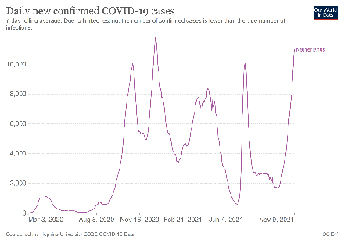  *10997 new cases recorded on 09.11.2021 | Infection rate (cumulated past 14 days): 762 cases per 100.000 inhabitants (up from 204 cases per 100.000 inhabitants on 8 September 2021)  On 10.11.2021, 71% of the population received at least one dose of Covid-19 vaccine and 64,7% of the population is fully vaccinated.  COVID certificate: The Covid entry pass is mainly used to lift social distancing requirements and capacity restriction rules in events and certain venues.  Bar/restaurant Nightclub Hotel Public transport Cultural events/ gatherings Gym/Sport facilities Shop/shopping mall Personal care services  COVID certificate required? Yes Yes No No Yes No No No  General information: Information about the current Dutch measures to control the spread of coronavirus in the Netherlands is available at www.government.nl. People are asked to work from home unless not possible.  As of 6 November people must show a coronavirus entry pass at more locations, which applies to bars and restaurants (indoor and outdoor, but not takeaways), events (such as festivals, concerts, professional sports matches), cultural venues (such as cinemas, museums, and theatres), and gyms. Everyone can participate in sports activities indoors and outdoors. Sports matches and competitions are permitted. For people without proof of vaccination or recovery, getting tested will remain free of charge. There are different rules for every sort of business.  There is no restriction in the number of visitors people can receive at home. The same applies to the number of people who can form a group, for example in a park or restaurant. No maximum number of visitors and no closing time for outdoor events but the corona pass is obligatory. There is no maximum number of visitors and no closing time for seated indoor events (but catering must be closed between 0.00 – 6.00). Indoor events without allocated seating may receive up to 75% of the max capacity of visitors.  All shops can open in accordance with their regular opening times. All shops in the Netherlands may be open for business. The 1,5 metre social distancing rule is replaced by an urgent advice to keep a safe distance but wearing a mask is mandatory. All other restrictions, for example on opening hours or sales of alcohol, are lifted and the corona entry pass system is not needed unless there is a catering facility.  Health protocols for tourism services and tourists. Recommended contact tracing app: CoronaMelder app  Hotels: Tourist accommodations are open. Campsites and holiday parks are open. Hotel restaurants are open and follow the same rules as restaurants.  Bars and restaurants: Establishments serving food and drinks are open but must provide assigned seats to all guests. All establishments close between midnight and 06:00 AM. This also apply for nightclubs which, without assigned seating, must limit their capacity to 75%. Members from different households must be seated 1.5 metres apart. This does not apply to children under the age of 13. Registration and a health check are mandatory. Discotheques and nightclubs are closed.  Travel restrictions: If you are travelling by air you must fill in a health declaration and carry it with you. The Netherlands adopts its own national classification of risk areas. Countries are classified as: very high risk with variants of concern, very high risk, high risk, or safe.  - EUDCCs holders allowed to enter if their certificate contains either a vaccination certificate, a recovery certificate or a negative Covid-19 test result.  - Low risk country: no need to take a test or to do a quarantine.  - High risk country: you need to show a negative Covid-19 test, or proof of vaccination, or proof of recovery of Covid-19.  - Very high risk country: added to the high risk requisites, a 10-day quarantine period is mandatory which can be shortened by getting tested on day 5.  - Very high risk with variants of concern or very high risk country: self-quarantine is mandatory, and you need to show proof of a negative Covid-19 test.
Norway  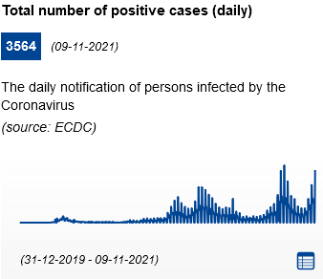 | Infection rate (cumulated past 14 days): 328 cases per 100.000 inhabitants (stable from 343 cases per 100.000 inhabitants on 8 September 2021)  On 09.11.2021, 77,1% of the population received at least one dose of Covid-19 vaccine and 68,8% of the population is fully vaccinated.  COVID certificate: The Covid entry pass is mainly used to lift social distancing requirements and capacity restriction rules in events and certain venues.  Bar/restaurant Nightclub Hotel Public transport Cultural events/ gatherings Gym/Sport facilities Shop/shopping mall Personal care services  COVID certificate required? No No No No No No No No  General information: Overview of rules and recommendations. In areas characterised by a higher epidemiological risk, further restrictions may apply: Local measures. Being physically present at work is now to some extent possible.  The rules and recommendations for events, leisure activities and social gatherings are now lifted. There is no longer need to keep a distance of at least one metre. Keeping a safe distance from others where possible can prevent transmission but is no longer a general recommendation. Recommendations to keep a safe distance and to reduce the number of contacts can still be given locally if the epidemiological situation makes it necessary. COVID-19 certificates are no longer in use at events in Norway but are still in use when travelling.  Hotels are open. Persons who are not permanent residents (as per the National Population Register) or do not have a suitable place of residence to implement their travel quarantine, must complete their quarantine duty period at a quarantine hotel.  Bars and restaurants are open without any restrictions.  Travel restrictions: there is implemented a colour system of classification. Norwegian citizens, residents in Norway, foreigners who are residents of a country or area classified as "green" from the epidemiological point of view. To travel Norway is needed:  - A valid Covid-19 certificate and being citizen or resident coming from the EU/EEA, Switzerland or , UK, (which can be red, orange, red, or dark red) or a purple territory.  - For grey countries (the rest), there must be a valid exceptional reason to enter.
Poland  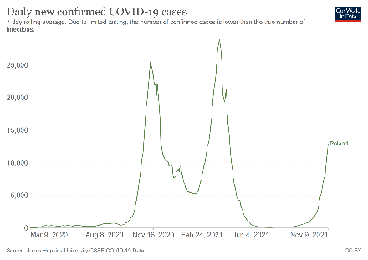  *12930 new cases recorded on 09.11.2021 | Infection rate (cumulated past 14 days): 378 cases per 100.000 inhabitants (up from 10 cases per 100.000 inhabitants on 8 September 2021)  On 10.11.2021, 56,8% of the population received at least one dose of Covid-19 vaccine and 53% of the population is fully vaccinated.  COVID certificate: The use of a pass is not necessary to access closed establishments. However, people who can prove vaccination do not count for the 75% capacity limit applied to most types of indoor establishments. The EU Covid certificate is used to facilitate access to the country.  Bar/restaurant Nightclub Hotel Public transport Cultural events/ gatherings Gym/Sport facilities Shop/shopping mall Personal care services  COVID certificate required? Yes (partially) Yes (partially) Yes (partially) No No Yes (partially) No Yes (for health venues)  General information: Temporary limitations - Coronavirus: information and recommendations. Note: the Polish government website outlines that many measures are valid until 31 October 2021; however there is no further information available regarding whether measures have been prolonged after 31 October 2021.The sections below therefore assumes that these measures have been prolonged.  Wearing a face mask covering mouth and nose is compulsory in closed public places. Up to 150 people may participate in events and meetings, either outdoors, indoors or in designated areas. A distance between tables must be maintained (only every other table may be occupied, with a 1.5 metres distance between tables, unless there is a screen between them with a height of at least 1 metre). A rule limiting capacity to 75% in many indoor venues applies including to theatres, concert venues, cinemas. Trade fairs, congresses and conferences can be organised provided that the limit of 1 person per 10m2 is maintained. Shopping centres and retail trade are open. A strict sanitary regime is in place and customer capacity may be limited (1 customer per 10 square metres). Hair-salons and beauticians are open. Swimming pools, water parks and closed sport facilities can operate with a limit of 75% occupancy. Vaccinated people are not counted in this limit. Valid until 31 October 2021  Health protocols for tourism services and tourists (in Polish) Recommended contact tracing app: ProteGO Safe.  Hotels: Hotels operate under a strict sanitary regime at no more than 75% occupancy. The limit shall not apply to persons fully vaccinated against COVID-19 and to groups of children under 12 years old. Hotel restaurants operate under a strict sanitary regime at no more than 75% occupancy. A distance between individual tables must be maintained. Valid until 31 October 2021.  Bars and restaurants: Restaurants operate under a strict sanitary regime at no more than 75% occupancy. A minimum distance of 1,5 metres has to be maintained between tables (unless there is a screen between them with a height of at least 1 metre, counting from the table surface). The limit does not apply to persons fully vaccinated against COVID-19 and to groups of children under 12 years old. Valid until 31 October 2021.  Travel restrictions: Poland adopts its own national classification of risk areas. Current information on persons allowed to cross the Polish border can be found on the website of the Border Guard. All passengers travelling by air are required to complete the Traveller Location Card.  - Travellers can enter Poland without being subject to further restrictions (testing or quarantine), if their 'EU Digital COVID Certificate' (EUDCC) contains proof of vaccination, recovery or test within 48 hours. Other forms of proof than the EU Covid certificate may be accepted. Travellers who do not hold any of these documents are subject to a 10-day quarantine upon entry,  - Regardless of the means of transport used (collective, individual, or when crossing the border on foot), travellers from EU/Schengen countries and Turkey, who don’t have a EUDCC or another official certificate stating they are fully vaccinated, they recovered from COVID-19 and they have a negative result to a COVID-19 test, are subject to a 10-day quarantine upon entry. Travellers who have been quarantined may perform a test on day 8 at the earliest from arrival. A negative test result releases them from quarantine.  - Travellers from non-EU / non-Schengen countries that have an agreement with Poland on the movement of people during the COVID-19 pandemic (listed by the Ministry of Foreign Affairs), can enter Poland at the same conditions as travellers from EU and Schengen Associated countries
Portugal  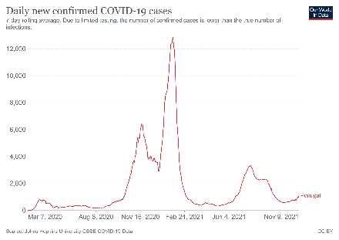  *1102 new cases recorded on 09.11.2021 | Infection rate (cumulated past 14 days): 128 cases per 100.000 inhabitants (down from 264 cases per 100.000 inhabitants in on 8 September 2021)  On 10.11.2021, 87,8% of the population received at least one dose of Covid-19 vaccine and 81,2% of the population is fully vaccinated.  COVID certificate: the EU COVID Digital Certificate or a negative Covid-19 test certificate is now only needed to access late night clubs, major cultural and sporting events, visits to health facilities, and travel by air or sea.  Bar/restaurant Nightclub Hotel Public transport Cultural events/ gatherings Gym/Sport facilities Shop/shopping mall Personal care services  COVID certificate required? No Yes Yes No Yes No No No  General information: Portugal is in a countrywide State of Alert, however, on the 1st of October 2021, the Government decided to move to the next and last phase of the Plan for the Gradual Lifting of Restrictions. There is no curfew or limitations to the opening and closing hours of services and businesses. Further detail on current measures is available here. There is no curfew or interstate travel restriction.  There is no longer capacity limits for weddings, baptisms, businesses, shops, or cultural shows. There is no timetable restrictions or limitation on the sale and consumption of alcohol. That said, the use of the mask is still mandatory in public transport, hospitals, shows and event rooms, and large surfaces; and also by workers in bars, clubs, restaurants and commercial and service establishments. Moreover, as general behaviour guidelines it remains in place social distancing, frequent hand washing and respiratory etiquette.  Hairdressers, manicurists, and barbers; schools and universities; and public services are fully open in-person.  Recommended contact tracing app: StayAway COVID  Hotels: A negative test result or a EU Digital Covid certificate (green pass) is mandatory to stay and overnight in touristic accommodations throughout the continental territory.  Bars and restaurants: a Covid pass is no longer needed to get in restaurants. There is no maximum limit of people per group neither or timetable restrictions. That said, a Covid certificate pass is needed to attend to late-night clubs.  Travel restrictions: All passengers need to fill a Passenger Locator Card before departure to Portugal. Portugal adopts its own national classification of risk areas. EUDCCs holders are allowed to enter Portugal without further restriction if their certificate contains either a vaccination certificate, a recovery certificate or a negative Covid-19 test result.  Non- EUDCCs holders:  - All travellers are subject to the requirement for a pre-departure negative COVID-19 test.  - Travellers from high risk countries are subject to the requirement for a pre-departure negative COVID-19 test and must complete a 14-day isolation period after entry to mainland Portugal.
Romania  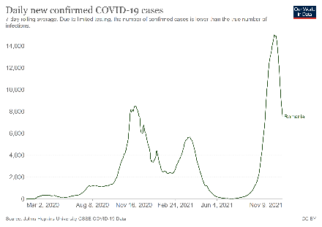  *7518 new cases recorded on 09.11.2021 | Infection rate (cumulated past 14 days): 684 cases per 100.000 inhabitants (up from 81 cases per 100.000 inhabitants on 8 September 2021)  On 10.11.2021, 37.9% of the population received at least one dose of Covid-19 vaccine and 33,9% of the population is fully vaccinated against Covid-19.  COVID certificate: The 'EU Digital COVID Certificate' (EUDCC) is necessary to access many places and events, as well as for employees of private sector establishments where 50 or more employees work simultaneously. It must contain proof of full vaccination (valid after 10 days after the vaccination cycle has been completed) or of recovery (between 15 and 180 days after being infected).  Bar/restaurant Nightclub Hotel Public transport Cultural events/ gatherings Gym/Sport facilities Shop/shopping mall Personal care services  COVID certificate required? Yes (incl. terraces) N/A Yes No Yes (if authorised) yes Yes (except essential shops) yes  General information: Information on the situation in the country is available on the National Platform for emergency preparedness, and on the official website on COVID-19 information. The current measures are valid from 25 October 2021 for a period of 30 days, regardless of the rate of infection. A curfew between 10pm and 5am is in place, but does not apply to vaccinated or recovered people.  The use of facemasks is mandatory in all indoor and outdoor public spaces, including public transport.  Private events (weddings, baptisms, birthdays, etc.) are banned. Rallies and demonstrations can take place under strict regulations (maximum 100 people; vaccinated or recovered only). Between 9pm and 5am, shops are closed and can only provide home deliveries.  The following types of establishments are only open between 5am and 9pm, only for people who are fully vaccinated or have recovered from COVID-19, and can operate at 30% capacity: Museums, libraries, bookstores; Cinemas, film and audio-visual production studios; Gyms and fitness centres; indoor swimming pools; gaming and gambling establishments.  Recommended contact tracing app: CovTrack  Hotels: Tourism services can provide accommodation only for customers who hold an 'EU Digital Covid Certificate' (EUDCC) with proof of full vaccination or recovery. Health Protocols for tourism  Bars and restaurants: Only people who are fully vaccinated or have recovered from COVID-19 can access restaurants and cafes, including terraces. They are closed between 9pm and 5am, and can only operate up to 50% capacity during opening hours. Only home delivery services are allowed after 9pm. Bars, clubs and discos are closed.  Travel restrictions: Romania adopts its own national classification of risk areas, based on three colours (green, yellow, red).  - “Green” or “yellow” areas: travellers in possession of an EU Digital Covid Certificate of vaccination or a Certificate of recovery can enter Romania and are exempted from quarantine or testing requirements. Travellers from “red” areas must show proof of vaccination or recovery (test only accepted for children between 12 and 16 years old). Under 12s can enter the territory without any requirements.  - “Green” area: Travellers do not need an EU Digital Covid Certificate and no quarantine is imposed.  - Travellers arriving from countries classified as "yellow", who do not provide an EU Covid Digital Certificate or pre-departure negative PCR test taken within 72 hours prior to arrival, are subject to a 14-day quarantine.  - “Red” area: Travellers need to do 14 days of quarantine, even if they present a negative test. The quarantine period may be shortened by taking a PCR test no less than 8 days after arrival. If the result of this test is negative, the period of quarantine can end on day 10.
Serbia  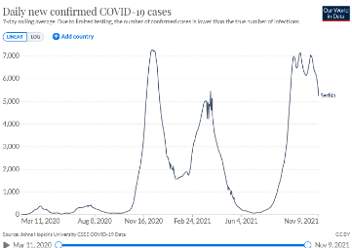  * 5246 new cases recorded on 09.11.2021 | Infection rate (cumulated past 14 days): 1172 per 100.000 inhabitants (up from 674 cases per 100.000 inhabitants on 8 September 2021)  On 09.11.2021, 46,4% of the population received at least one dose of Covid-19 vaccine and 44,1% of the population is fully vaccinated.  General information: Details available here. People are free to move within the country. Working from home is strongly encouraged.  Protective face masks are mandatory in all public spaces, both indoors and outdoors when the area is crowded. Failure to wear a mask when required will incur a fine. Self-isolation, when required, will be enforced.  Up to 500 people are allowed to meet indoors or outdoors. Events expecting over 500 people must get permission from the Crisis Response Team.  All retail stores may remain open 24 hours, seven days a week.  All operating facilities must provide a minimum of 9 m2 per person. Exceptions are fitness centers, spa centers, gyms, and similar facilities which must provide 16 m2 per person. This number includes the staff at these businesses.  Hotels are open. Restaurants within hotels may serve guests.  Bars and restaurants: Cafes, bars, and restaurants may now operate outdoor facilities with no closing time. Indoor facilities may operate until 1:00 a.m. Music is now allowed.  Travel restrictions: Foreign citizens are allowed to enter the Republic of Serbia provided that they have one of the following documents: a negative PCR test, a certificate of complete vaccination or a certificate of overcome COVID-19 disease. Restrictions are lighter for Serbian nationals. Further details are available here.
Slovakia  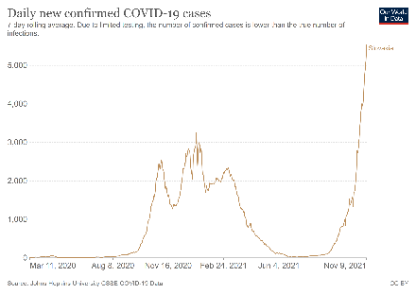  * 5527 new cases recorded on 09.11..2021 | Infection rate (cumulated past 14 days): 1214 cases per 100.000 inhabitants (up from 53 cases per 100.000 inhabitants on 8 September 2021)  On 10.11.2021, 46% of the population received at least one dose of Covid-19 vaccine and 44,8% of the population is fully vaccinated.  COVID certificate: The VTR (Vaccinated, Recovered, Tested) rule applies to manage admittance to most indoor public facilities, with a mix of mandatory and optional requirements for establishment owners or event organisers, depending on local alert levels. The EU Digital Covid certificate is used for travel-related measures to prove vaccination (recovery or test insufficient).  Bar/restaurant Nightclub Hotel Public transport Cultural events/ gatherings Gym/Sport facilities Shop/shopping mall Personal care services  COVID certificate required? Yes (partially) No Yes (optional) No Yes (partially/optional) No No No  General information: The measures and restrictions in a given district may change according to the local epidemiological situation, as set out in a framework known as the ‘Covid Automat’. Each district of Slovakia is evaluated every week according to its epidemiologic situation. There are 5 different levels of alert.  Face masks must still be worn in all indoors areas (except for households), outdoors in high infection areas, and at mass outdoor events. Conditions for mass gatherings and events depend on the local level of alert. Event organisers have the possibility to set their conditions (different conditions apply on local level of alert)) for entry to their establishments / events: either entry for only fully vaccinated persons – no or very soft capacity limits and protective measures; or entry for VTR (vaccinated, tested, recovered) – stricter capacity limits and protective measures; or entry for all persons – very strict capacity limits and protective measures. Unless otherwise stipulated, a limit of one person per 15 square metres applies to establishments. Generally, mass events and gatherings in level 5 alert districts are prohibited.  Regarding shops, no capacity limits apply to the two lower tiers of alert areas. The ban on the consumption of meals and beverages inside department stores remains in existence. This does not apply to mass catering facilities in department stores, where conditions valid for the establishments of mass catering facilities are followed. Swimming pools and fitness centers are open, with a maximum occupancy of 6 people. Entrance to cultural venues is also conditioned to the local level of alert and application of the VTR rule.  Hotels: Capacity limitations do not apply in the least affected areas (two lower level alert tiers). In all the other levels, entry to fully vaccinated persons or VTR (vaccinated, tested, recovered) persons can be allowed, based on the preference of the accommodation operator. Accommodation operators are entitled to request from a guest a proof of vaccination, a negative test result or a proof of recovery, also in the form of EU Digital Covid Certificate, upon entry to the establishment.  Restaurants and bars: In the districts of the three higher alert levels, it is prohibited to consume meals and beverages indoors and outdoors, unless the VTR rule is applied. Take away is permitted. In the two lower level alert districts, indoor and outdoor dining is allowed under specific conditions.  Travel restrictions: All travellers entering the Slovak Republic must register here. People arriving in the Slovak Republic by air are also obliged to fill in the passenger locator form.  Only and exclusively fully vaccinated people who have received both doses of a two-series vaccine are considered as low risk. Such persons do not require to enter quarantine or self-isolation measures when entering Slovakia. All unvaccinated entering Slovakia are required to enter a mandatory self-isolation and undertake an RT-PCR test (earliest on the 5th day of self-isolation) regardless of the country in which they have stayed for the last 14 days. The same rules apply to travellers regardless of their origin.
Slovenia  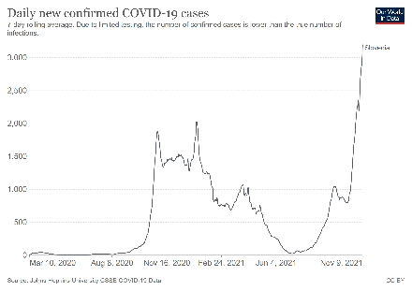  *3195 new cases recorded on 09.11.2021 | Infection rate (cumulated past 14 days): 1813 cases per 100.000 inhabitants (up from 347 cases per 100.000 inhabitants on 8 September 2021)  On 10.11.2021, 56.7% of the population received at least one dose of Covid-19 vaccine and 53,7% of the population is fully vaccinated.  COVID certificate: The RVT (Recovered, Vaccinated, Tested) scheme is applicable in several types of establishments and venues. Since 15 September 2021, the Recovered - Vaccinated – Tested rule must be met by all employees as well as all users of services or activities, except in cases of the emergency supply of basic necessities of life, the provision of public order, security and defence, emergency medical assistance and protection and rescue. The RVT rule also applies to use public facilities such as beaches and ski lifts.  Bar/restaurant Nightclub Hotel Public transport Cultural events/ gatherings Gym/Sport facilities Shop/shopping mall Personal care services  COVID certificate required? Yes Yes Yes Yes (exceptions for students and puils) Yes Yes Yes (except for essential shops) Yes  General information: General measures against coronavirus infection.  Masks must be worn in all closed and open (if social distancing cannot be ensured) public spaces. Guests seated at a table in the hospitality sector can remove the mask (RVT rule applies).  Gatherings (socialising) are temporarily prohibited, and are only permitted for groups of persons who are immediate family members or share the same household. All public events, public gatherings, celebrations, and wedding ceremonies are temporarily prohibited, unless otherwise provided for in ordinances or other acts of the Government of the Republic of Slovenia. The organisation of public cultural events in open public spaces is not permitted, but it is permitted in enclosed public spaces with fixed seating, whereby every other seat must be left vacant, the use of face masks is mandatory, and all participants must comply with the RCVT rule.  Recommended contact tracing app: #OstaniZdrav  Hotels: As stipulated by the RVT rule, staying at tourist facilities in the Republic of Slovenia is only possible for persons who present a certificate of a negative PCR or rapid antigen test result, a certificate of recovery from COVID-19, a vaccination certificate, or a certificate confirming that they have recovered from COVID-19 and have been vaccinated. Undergoing quarantine at tourist facilities is not possible under any circumstances.  Bars and restaurants: As stipulated by the RVT rule, only guests who have either a certificate of a negative COVID-19 test result, a proof of vaccination against COVID-19 or a doctor’s certificate stating that they recovered from COVID-19 may stay inside facilities.  Travel restrictions: All passengers must submit a passenger locator form upon arrival. Passengers from any country are allowed to enter the country if they present a negative PCR test, a certificate of recovery, a certificate of vaccination, a European digital COVID certificate or a digital COVID certificate of third countries. A person who does not provide one of the above is referred to quarantine at home for a period of 10 days.
Spain  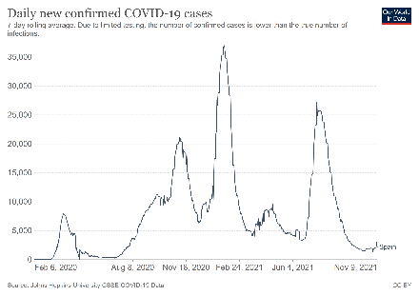  *2155 new cases recorded on 09.11.2021 | Infection rate (cumulated past 14 days): 60 cases per 100.000 inhabitants (down from 197 cases per 100.000 inhabitants on 8 September 2021)  On 10.11.2021, 80,5% of the population received at least one dose of Covid-19 vaccine and 73,9% of the population is fully vaccinated.  COVID certificate: Although Spain as a whole has not introduced a green pass requirement, some regions (e.g; Galicia, Canaries) have.  Bar/restaurant Nightclub Hotel Public transport Cultural events/ gatherings Gym/Sport facilities Shop/shopping mall Personal care services  COVID certificate required? No (indoors for some regions) No (indoors for some regions) No No No No No No  General information: infections levels are low and stable and therefore there are no national restrictions rather than the use of mask in indoor public spaces and transport. That said, regional and local governments are allowed to impose any restrictions deemed necessary. There is no curfew and it is possible to move around the whole country.  Outdoor social gatherings are not limited nationally. Physical distancing measures must be guaranteed and the maximum precautions must be taken to avoid meetings and overcrowding in indoor places.  Shops are open. Shops must ensure that disinfection measures and social distancing are applied. Special attention is required in commercial areas and street markets. Restrictions can differ between autonomous regions. Small businesses (as hairdressers) are open.  The contact tracing app Radar Covid is currently being rolled out in regions across Spain after a pilot test in La Gomera.  Recommendations from the Spanish government for the service industry (in Spanish).  Guide of regional and local restrictions (in Spanish).  Hotels: Occupancy is often limited, especially at the reception and in common areas. There can be restrictions on valet parking and ironing services. In-house catering services have to comply with the general disinfection and social distancing measures, as well as restricted opening hours. There may be temporary limitations on the number of guests per table. All tourist services should ensure everyone’s safety, based on three essential principles: social distancing, hygiene, and responsible behaviour. Measures may be changed when necessary to respond to the local COVID-19 situation.  Bars and restaurants: Autonomous Regions are the competent authorities regulating access to these places. Autonomous Regions might require the EU Digital COVID certificate (or equivalent) to access indoor bars and clubs. Checking the regional websites is highly recommended for being updated with the new possible regulations. For restaurants, there is usually no limits of persons per table and full capacity is allowed. For more info: Recommendations from the Spanish government for the service industry.  Nightclubs have reopened. Requirements and opening hours depend on the region. Masks shall remain on when not eating or drinking. Here it can be checked if there are any specific regional restrictions (in Spanish).  Travel restrictions: If you travel by air, a form must be completed and signed electronically before the arrival in Spain. If you travel by sea, a form must be completed and signed electronically before boarding.  - To enter Spain, travellers must present the EU Digital COVID Certificate or equivalent proof.  - For passenger who do not have the EU Digital COVID Certificate, if they come from a country/area considered at risk for COVID-19, they must present a certificate or document certifying vaccination, an active infection diagnostic test (AIDT) or recovery from COVID-19. (see here)  - Passengers from third countries who meet the requirements to enter Spain as listed on the Government's website, may travel by presenting either a certificate of vaccination, a negative diagnostic test or a certificate of recovery from COVID-19
Sweden  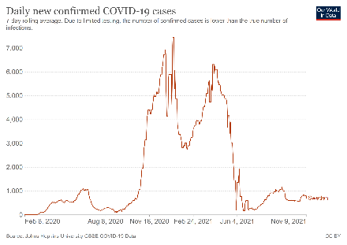  * 702 new cases recorded on 06.09.2021 | Infection rate (cumulated past 14 days): 107 cases per 100.000 inhabitants (down from 134 cases per 100.000 inhabitants on 8 September 2021)  On 10.11.2021, 70,3% of the population received at least one dose of Covid-19 vaccine and 67,2% of the population is fully vaccinated.  COVID certificate: The Covid certificate is required for travel purposes only.  Bar/restaurant Nightclub Hotel Public transport Cultural events/ gatherings Gym/Sport facilities Shop/shopping mall Personal care services  COVID certificate required? No No No No No No No No  General information: Sweden has adopted a set of general guidelines to avoid the spread of Covid-19.  There is no general requirement to wear a face mask in normal social situations, in public places, and in public transport.  The maximum number of participants allowed at indoor events without designated seating is 50 participants, in indoor events with designated seating it is 300 participants, at outdoor events without designated seating it is 600 participants and at outdoor events with designated seating it is 3000 participants. If a private gathering is held at an event venue, in a meeting room and at other rented premises, a maximum of 50 people are allowed to attend.  Non-essential shops and personal care services are open, but may have reduced opening hours and limits to the number of customers allowed. Personal care services are open, taking into account required precautions.  Hotels: All businesses are obliged to take measures to reduce the risk of the spread of infection, for example by limiting the number of guests staying at the same time in a room such as arrangements to avoid queuing, a limit to the number of guests, social distancing, and hygiene measures. If there is a restaurant, bar, café or similar facility at the accommodation, it will be covered by the new rules for restaurants and bars.  Bars and restaurants: are open. Maximum 8 people are allowed to sit at the same table. Guests must respect physical distancing; food and drinks must be served at the table; guests must always eat their food while seated at a table.  Visita has launched a campaign that consists of three brochures including measures preventing infection in restaurants, hotels and campsites: Information for restaurants  Travel restrictions: Until at least 30 November 2021, adult citizens travelling from any EU Member State or Schengen Associated country (except for Nordic countries) need to have and EU Covid certificate or equivalent proof of vaccination, recovery or negative test. People are encouraged to get tested upon arrival, even if vaccinated or recovered, until at least 31 December 2021. There is an entry ban and required negative covid test in effect for travels to Sweden from non-EU Member States or Schengen Associated countries until 31 January 2022 (does not apply if traveller is vaccinated or has an EU covid certificate, or meets an exception category - e.g. Swedish citizen or resident, diplomat, health care corker, parent visiting child residing in Sweden).
Switzerland  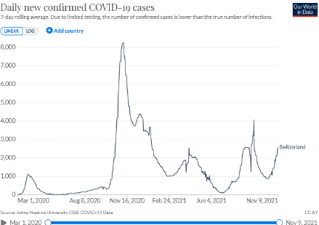  * 2575 new cases recorded on 09.11.2021 | Infection rate (cumulated past 14 days): 360 cases per 100.000 inhabitants (down from 423 cases per 100.000 inhabitants on 8 September 2021)  On 08.11.2021, 66% of the population received at least one dose of Covid-19 vaccine and 64% of the population is fully vaccinated.  COVID certificate: The use of the Covid certificate in Switzerland depends on the epidemiological levels of the locality. It is not required in green areas, optional in orange areas and mandatory for opening large-scale events in red areas and in general for nightclubs. Further details available here.  Bar/restaurant Nightclub Hotel Public transport Cultural events/ gatherings Gym/Sport facilities Shop/shopping mall Personal care services  COVID certificate required? No (optional) Yes No No Yes (partially/optional) Yes (partially/optional) No No  General information: Where the cantonal measures are stricter than the national measures, then these must be observed. The links to information provided by the cantons can be found on the website www.ch.ch (in German, French or Italian).  The requirement to work from home has been downgraded to a recommendation.  Masks must be worn in many public spaces, for example in shops, in restaurants, on public transport and in busy pedestrian zones. The number of people allowed to attend private events with friends and family is limited to maximum 30 people indoors, and maximum 50 people outdoors.  Large-scale events with more than 1,000 people may only be attended by people with a valid COVID certificate. In addition, the organisers of large-scale events must obtain authorisation from the cantonal authority. There will be no restrictions on events at which access is limited to people with a COVID certificate, including large-scale events. Without a covid certificate requirement, events may gather up to 1000 seated people both indoor and outdoors, or 250 non-seated people indoors or 500 non-seated people outdoors; masks must be worn at indoor events; up to two-thirds of the venue’s capacity may be used indoors or outdoors; events and concerts involving dancing are not allowed.  All shops are open. There are no longer any restrictions on opening hours for service businesses. Cultural establishments, cinemas, theatres and museums are open with a limited capacity.  Recommended contact tracing app: swisscovid-app. The "Clean & Safe" campaign establishes safety protocols for service providers.  Hotels: are open. Hotel facilities (e.g. spas and restaurants) reopened to tourists. Restaurants for hotel guests and restaurants have also reopen. Tourist accomodations are open and respect the national non-pharmaceutical measures.  Restaurants and bars: Bars and restaurants are open. However, for people aged 16 and over access to indoor areas of restaurants and bars where people consume food and drinks on the premises must be restricted to holders of a valid COVID certificate. Guests are then no longer subject to restrictions such as the requirement to wear a mask.  Travel restrictions: All travellers entering Switzerland by air need to fill the entry form swissplf.admin.ch. The Federal Office of Public Health provides a regularly updated list of countries defined as COVID-19 risk area, so called countries or areas with variants of concern.  - Holders of ‘EU Digital COVID Certificates’ (EUDCC) or recently recovered from Covid-19 in the last 6 months only need to show an entry form and COVID certificate on arrival in Switzerland without any sort of test requirement  - Non-Holders of ‘EU Digital COVID Certificates’ (EUDCC) have to provide proof of a negative PCR (not older than 72h) or antigen test (not older than 48h) on entry, an 4-7 days after arrival. This test result must be reported to the canton within 2 days.
Turkey  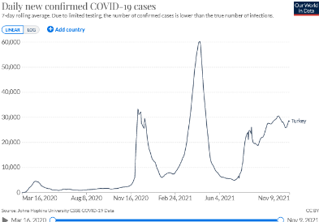  * 28 386 new cases recorded on 09.11.2021 | Infection rate (cumulated past 14 days): 448 cases per 100.000 inhabitants (up from 334 cases per 100.000 inhabitants on 8 September 2021)  On 09.11.2021, 65,5% of the population received at least one dose of Covid-19 vaccine and 58% of the population is fully vaccinated.  General information: Provinces in Turkey are split into four tiers by COVID-19 risk: low, medium, high and very high. A map of Turkey illustrating these tiers is available from the Ministry of Health. In July Turkey entered into the last phase of the normalization process where all remaining restrictions concerning the curfews and restaurant working hours are lifted and public life returned to normal.  From 6 September, Turkish citizens and residents must have proof of either two Covid vaccinations or recent Covid recovery (linked to the HES code) or a negative PCR test (within 48 hours) for all domestic travel by planes, and inter-provincial travel, including buses, trains or other public transportation vehicles. An HES (Hayat Eve Sigar) Code for domestic and international flights, train and ferry travel is also required. In addition, the HES code will be required when checking into accommodation including hotels, motels, boarding houses, pensions, camps etc. Some provinces also require submission of a HES code upon entry to public buildings, shopping malls and banks. This does not apply to foreign tourists.  All persons nationwide must wear protective facemasks and observe social distancing while in public. Strict social distancing guidelines have also been imposed on public transport.  Shopping centres, markets, restaurants and hairdressers will be open as their registration permits as usual. Food markets, including greengrocers, butcher shops, bakeries, and confectioners shops, as well as supermarkets are open without limitations.  Movie theatres, amusement and theme parks, game/billiard halls, soccer fields, swimming pools, gyms, Turkish baths, saunas, and massage parlours are permitted on all days of the week.  Hotels are open. Restaurants in hotels/accommodation facilities are open for all guests.  Bars and restaurants: Dining establishments such as restaurants, patisseries, cafés, and cafeterias is open for in-person dining and delivery services. Restrictions still apply in hookah bars and lounges.  Travel restrictions: From 6 September, Turkish citizens and residents must have proof of either two Covid vaccinations or recent Covid recovery (linked to the HES code) or a negative PCR test (within 48 hours) for all domestic travel by planes, and inter-provincial travel, including buses, trains or other public transportation vehicles.  All incoming passengers must complete a “Traveler Entry Form” at least four days before their arrival in Turkey. Turkey accepts tourists from most countries of the world without any quarantine requirement. Travellers who are fully vaccinated or who have overcome the disease during the last six months can enter Turkey without restriction (except ‘suspended countries such as Brazil, India or South Africa). Otherwise they must submit a negative PCR test obtained within the last 72 hours prior to arrival.
United Kingdom  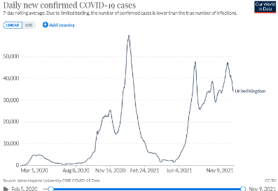  * 34 004 new cases recorded on 09.11.2021 | Infection rate (cumulated past 14 days): 758 cases per 100.000 inhabitants (stable from 741 cases per 100.000 inhabitants on 8 September 2021).  On 03.11.2021, 73,7% of the population received at least one dose of Covid-19 vaccine and 67,3% of the population is fully vaccinated.  COVID certificate: The NHS Covid pass has been implemented and its use is encouraged for nightclubs and large-scale events. Vaccine passports in nightclubs and other indoor venues in England will be required at the end of September. The Scottish Government also wants to introduce rules which would require all over-18s to prove their vaccine status for entry to nightclubs and many large events in Scotland from later in September. This would apply to indoor and outdoor events, including nightclubs, football matches, concerts and music festivals.  Bar/restaurant Nightclub Hotel Public transport Cultural events/ gatherings Gym/Sport facilities Shop/shopping mall Personal care services  COVID certificate required? No Optional No No Optional No No No  General information: the four home nations (England, Scotland, Wales and N. Ireland) apply measures differently. Most legal restrictions to control COVID-19 have been lifted, except in Northern Ireland.  In England, there is no more limit on how many people can meet privately and publicly. The social distancing has been removed. Nightclubs can reopen. Pubs and restaurants no longer table-service only. There is no more limit on the number of people attending concerts, theatres or sports events. The government will no longer advise people to work from home, or limit travel.  Scotland is currently at Level 0. Face coverings is compulsory on public transport and inside places like shops. People continue to be advised to work from home where possible. Physical distancing is not required anymore. There is no more limit on the size of social gatherings. All venues are allowed.  In Wales, there is no legal limits on the number of people who can meet indoors, including private homes, public places and events. All businesses and premises can open, including nightclubs. In Northern Ireland, the number of people allowed indoors in domestic settings rises from 10 to 15 from four households. Table service rules are lifted for pub and restaurant customers indoors and outdoors. Nightclubs remained closed and dancing is not permitted in indoor venues. Social distancing requirements still apply and face masks are generally required in closed public spaces.  Hotels: Hotels, hostels and B&Bs reopened to tourists across the UK  Bars, pubs, cafés and restaurants: In England, Wales and Scotland, pubs, restaurants and other hospitality venues are allowed to seat customers indoors without limitations. Restrictions still apply in Northern Ireland (see above).  Travel restrictions: All inbound travellers must submit a passenger locator form.  - Passengers from a country of the red list must take a COVID-19 test, quarantine in a hotel and take 2 COVID-19 tests, regardless of their vaccination status.  - Passengers from a country of the amber list must take a COVID-19 test 3 days before the arrival, book and pay for COVID-19 tests after arrival in England, quarantine at home for 10 days. Adults who are not fully vaccinated need to take an additional PCR test on or after day eight. The vast majority of countries are on the amber list.  - Passengers from a country of the green list must take a COVID-19 test 3 days before their travel to England, book and pay for COVID-19 tests to be taken after their arrival in England and take a COVID-19 test on or before day 2 after you arrive.
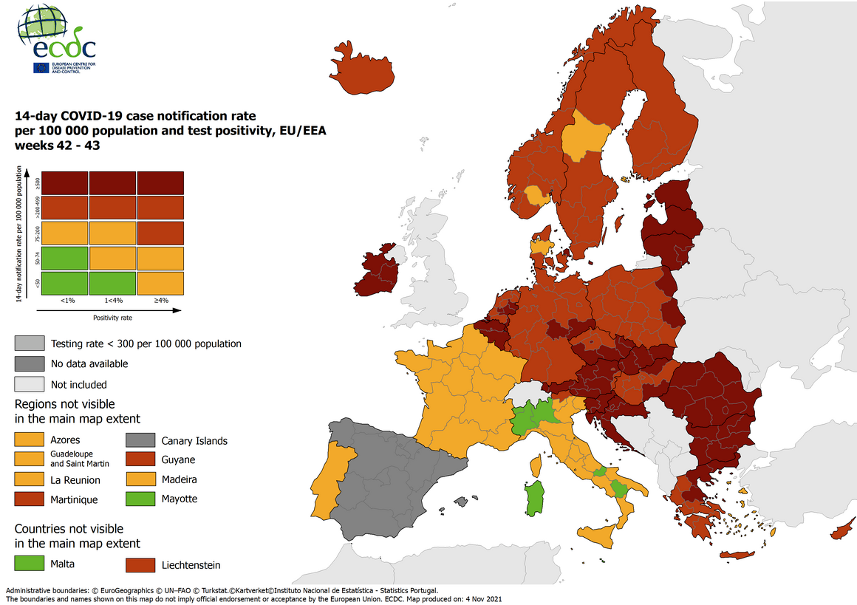
Combined indicator: 14-day notification rate, testing rate and test positivity, updated 10 November 2021.

